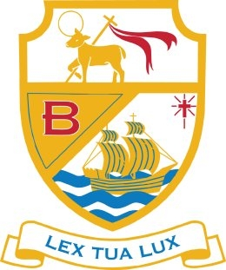

Vacancy for Teacher of Science 0.4 FTE (days to be agreed)

Permanent post to commence 1st September 2021
Salary Main Pay Range/UPS3 (pro rata)

The Governors wish to appoint a committed, enthusiastic and innovative Science teacher to join the outstanding Science Department at St Bede’s Catholic High School.

All applications, by letter and CES application form, should be emailed to j.taylor@sbchs.co.uk marked for the attention of Mr P Denton, Headteacher, and be received by 9.00am on Monday 12th April 2021. Interviews will take place during the week commencing 19th April 2021.

Letters, which should be no more than two sides of A4, should address your suitability for the post. Applicants will be expected to teach all 3 sciences to GCSE level.

Job description and person specification is available to download from the school website www.sbchs.co.uk or by contacting Miss J Taylor, j.taylor@sbchs.co.uk

