Crawshawbooth Primary School
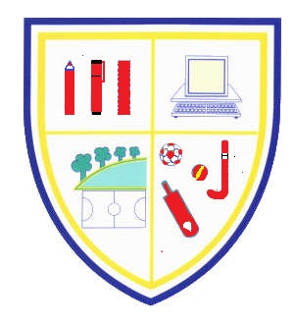
Burnley Road, Crawshawbooth, Rossendale, BB4 8AN
Tel: (01706) 228664
E-mail: head@crawshawbooth.lancs.sch.uk www.crawshawboothprimary.co.uk
HEAD: Mrs D Bonney M.A., B.Ed (Hons)

Dear Applicant

Thank-you for your interest in the post of Deputy Headteacher at our school.

Crawshawbooth Primary School is a large community school within a pleasant area of the Rossendale Valley. Pupils at school are well-behaved and have good attendance. Visitors regularly comment upon the welcoming ethos and our mission statement underpins our aims.

We pride ourselves on the good reputation of the school within the community. We have extremely supportive parents who value our rich and broad curriculum, making use of our fantastic Outdoor Studio and Secret Garden. The governors of the school are pro-active and
committed to continuously improving standards.

The school is ready to move forward to its next phase of development by further improving expectations and challenges for all our pupils who are motivated to learn.

We are looking for a highly professional person who is an outstanding teacher, with high expectations for the progress that pupils can make with a desire to improve standards even further by leading and supporting colleagues.

We are proposing a tour of the school on Friday 16th April at 9.30 am subject to the school's current Coronavirus Risk Assessment. Please contact the school office on 01706 228664 or email head@crawshawbooth.lancs.sch.uk to confirm your visit.

Please look at our website at www.crawshawboothprimary.co.uk for further information.
We look forward to receiving your application.

Yours faithfully,

Mrs Debbie Bonney MA, B.Ed (Hons) Mrs Emma Smurthwaite
Headteacher Chair of Governors

