Headteacher Paula Barlow

Dear Applicant,

Thank you very much for your interest in our advertised post and for considering Acorns to be the next step in your career.

There is more information about our school on the website which is: [www.acorns.lancs.sch.uk](http://www.acorns.lancs.sch.uk)

A copy of the job description, person specification and application form are attached to the advert.

We are excited about the prospect of welcoming a new member of staff to our school family. The person who is appointed will be hardworking, making a positive difference to the school, and education of our delightful pupils.

If you believe that you are this candidate, please complete the application form and return electronically to

sbm@acorns.lancs.sch.uk

We look forward to receiving your application

Yours sincerely

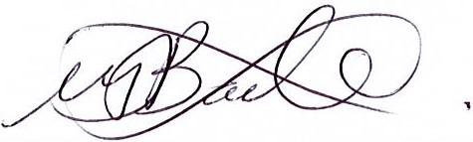

Paula Barlow

Headteacher