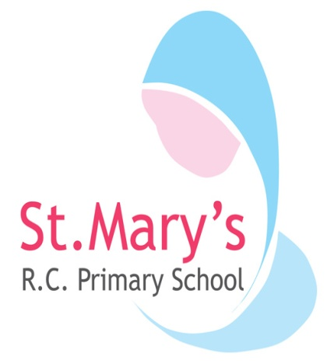**We live, learn and grow together with Jesus**

Mayfield Avenue, Oswaldtwistle BB5 3AA Tel: 01254 231278

Headteacher:Mrs LJ Wolstenholme head@st-marys-oswaldtwistle.lancs.sch.uk

Dear Applicant,

Thank you for your interest in our current position Lunchtime Welfare Assistant.

Saint Mary’s is a fantastic Primary School in Oswaldtwistle. We receive 40 children each year and have some mixed year group classes. We currently have 265 children on role. The school’s Catholic identity permeates all aspects of school life and our Catholic values underpin our whole curriculum. We value each and every one of our pupils and nurture their talents as individuals. We are a welcoming school community and look forward to appointing a mentor who can help us in nurturing and supporting our children and their families.

In December 2022 school gained a ‘good’ Ofsted report and in February 2020 we gained an ‘outstanding’ Section 48 RE inspection from Salford Diocese. St Mary’s has been an Eco school for over 19 years and love to take care of our school environment and beyond. Our children and staff are proud to say they belong to the Saint Mary’s family.

Any further information can be found by contacting school on 01254 231278. Applications should be returned to school via EMAIL (a.bentley@st-marys-oswaldtwistle.lancs.sch.uk) or POST by 12 noon on TUESDAY 3rd JUNE 2025 at 12pm.

Kind regards,

Mrs LJ Wolstenholme

Head Teacher