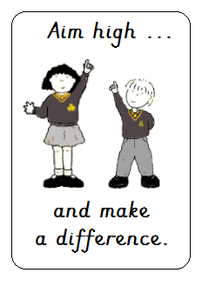Beaufort Road, Morecambe, LA4 6UB

(01524) 416971

[office@greatwood.lancs.sch.uk](mailto:office@greatwood.lancs.sch.uk)

[head@greatwood.lancs.sch.uk](mailto:head@greatwood.lancs.sch.uk)

**Job Description – Teaching Assistant Level 2b (Grade 5)**

**Main activities**

* Working with school systems to safeguard children
* Developing positive relationships with children, staff and parents
* Supporting teaching and learning of individuals, groups and whole class
* Supporting children with SEND and / or challenging behaviour
* Contribute to and evaluate children’s action plans linked to SEND and / or behaviour
* Using positive behaviour management strategies consistently
* Implementing and adapting learning activities / programmes for individuals and groups
* Promote good progress in continuous provision and in phonics and early reading when in EYFS and KS1
* Providing immediate and purposeful feedback to children to support learning
* Monitoring and recording pupil progress, including formal assessments
* Use ICT effectively to support teaching and learning
* Creating relevant classroom resources to support teaching and learning
* Contributing to a supportive and nurturing learning environment
* Following appropriate training, supporting children’s medical / health needs
* Providing short term cover for a class when the teacher is absent from the room
* Administer First Aid, when trained, to pupils following school procedures
* Follow the school’s confidentiality, safeguarding and health & safety policies
* Have a flexible, positive and hardworking attitude to work
* Using your initiative, work independently to prioritise and complete tasks
* Work effectively and collaboratively with others in different teams
* Maintain high levels of integrity and confidentiality

**Continuing Professional Development**

* Identify and attend relevant CPD and implement relevant strategies
* Respond positively to and implement as necessary any feedback from colleagues

**Other**

* Commitment to take an active part in the wider life of the school
* Willing to share personal skills and talents with the school
* Commitment to welfare and other roles depending on the needs of the school
* Excellent health, attendance and punctuality
* Neat, tidy and professional appearance