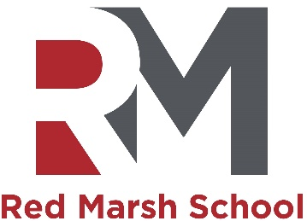
TA 1 posts
Due to the exciting expansion of Red Marsh School, now a two-campus school, we are looking to increase our amazing staff team.
Permanent Variable hours, working 30 hours per week, (guaranteed minimum of 3 hours) term time plus 5 INSET days.
Red Marsh School is an outstanding special school and National Support School which caters for pupils with severe and profound learning difficulties aged 2 to 19 years old. In this role you will be working in a dynamic and forward thinking team. Experience of working in an educational setting supporting pupils with their learning, behaviour and personal and social development is desirable. However, we welcome applications from candidates who are interested in developing a career in education, are highly motivated and committed to working hard as part of our school team.
We are committed to safeguarding and promoting the welfare of children and young people and we expect all staff to share this commitment. The successful candidate will share the schools values and purpose and be prepared to work at either Holly or Willow Campus. The successful applicant will be required to complete an enhanced DBS check. If you feel you have the skills and experience, as outlined in the TA1 permanent job description, we look forward to receiving your application.
Essential experience
Candidates must be highly motivated and committed to working with pupils with SEND.
Desirable experience
It is desirable that candidates are competent in the use of ICT.
It is desirable that candidates have a minimum of Grade C in English and Mathematics.
Red Marsh School is an Equal Opportunities Employer welcoming applications from all sections of the community.

Closing date: Noon on Thursday 23rd May 2024
Interviews to take place after the half term break in June TBC

