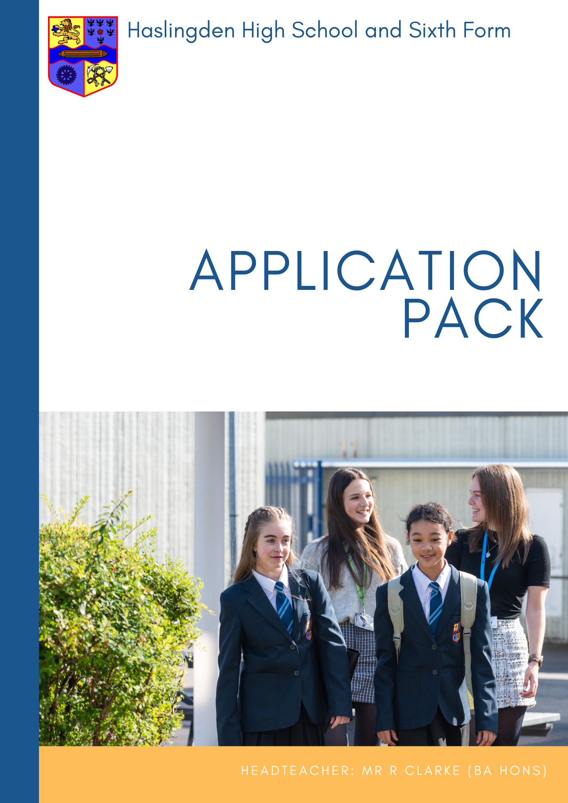
Library Assistant
Closing date for applications: Wednesday 3 July 2024
Interview date: Tuesday 9 July 2024
Part time 0.4 = 2 days/week (15 hours/week)
Permanent, term time only + 3 INSET days
08:00 – 16:00
Grade 4 Point 4-6 £8,047 - £8,318 (Actual Salary)

We are currently seeking to appoint a hardworking, committed and enthusiastic individual to work part time within our School Library. We are looking for someone who enjoys working as part of a team and prides themselves on a high standard of work. A sense of humour, a smile and empathy for young people and colleagues are all essential characteristics needed to be successful in this post. If this sounds like you, we look forward to reading your application.

Further details and an application form are available on our web site: www.haslingdenhigh.com/vacancies

Haslingden High School & Sixth Form is committed to safeguarding and promoting the welfare of children and young people and takes its statutory duties and responsibilities in this context very seriously. We fully expect everyone working in or behalf of the school to share our commitment. As such, this post is subject to satisfactory DBS clearance and references.

Library Assistant
Required September 2024

Haslingden High School and Sixth Form
Headteacher: Russell Clarke (BA Hons)

Dear Applicant,

Thank you for your interest in the post of Library Assistant at Haslingden High School and Sixth Form.

The Governors are seeking to appoint an enthusiastic, skilled and dedicated Library Assistant to support the school’s drive towards ‘Achievement for All’. The successful candidates should have experience against the job description accompanied by a successful track record.

Haslingden High School and Sixth Form is a high performing school and has an excellent reputation both locally and beyond. The school is significantly oversubscribed for the 270 places available annually in Year 7. We have wonderful students who are proud to be part of our school; a committed, talented staff and excellent facilities. We can look to the future, however uncertain it currently appears nationally, with confidence. We were inspected by Ofsted in May 2022 and they acknowledged the many significant strengths of the school in what is a very pleasing report, rating it as good.

Our GCSE results have been consistently strong in recent years. Our students performed exceptionally well given the challenges that they have faced and we remain very proud of all we have achieved together as a school community. We have a successful sixth form where students make strong progress and many of them choose to go on to university, the vast majority at their first choice of establishment.

In order for our school to operate in a smooth and effective manner, we know that we need the support of all colleagues and teams. We are very fortunate that our support staff are a highly effective and hardworking team who underpin all the great work that we do.

Haslingden High School and Sixth Form seeks to provide an outstanding holistic education for our students. Whilst achieving fantastic examination results is one of our core aims, our remit is much wider. We endeavour to equip all our students with the skills for further study and the world of work; provide them with the tools to develop their own set of values and beliefs conducive to being a good citizen; and provide an extensive range of extra-curricular activities for students to develop their own interests and aptitudes.

The successful applicant will find caring, friendly and supportive colleagues, committed to providing the very best life chances for all our students. We look forward to receiving your completed application form outlining your skills and experience. The closing date for applications is Wednesday 3 July 2024 at 9.00 am with interview date Tuesday 9 July 2024.

Haslingden High School and Sixth Form is committed to safeguarding and promoting the welfare of children and young people and takes its statutory duties and responsibilities in this context very seriously. We fully expect everyone working in or on behalf of the school to share our commitment. As such, this post is subject to satisfactory enhanced DBS clearance and references.

Yours sincerely

Mr R Clarke
Headteacher

- Create successful learners, who achieve the best possible qualifications, alongside equipping them with the skills and motivation to overcome future challenges

- Ensure all students experience an exciting, ambitious and inclusive curriculum that is well-planned, broad, diverse and expertly delivered. Our curriculum will inspire and motivate all students to want to know and remember more, allowing them to become lifelong learners

- Provide access to a wide range of opportunities and experiences beyond the taught curriculum, enabling all our students to leave our school with high aspirations

- Work in partnership to offer a personalised approach to care, guidance and support that will ensure all students feel and know how to keep themselves safe and happy. Students’ physical, mental and emotional wellbeing is at the forefront of everything we do, empowering them to make informed choices

- Guide students, helping them to become kind, resilient and ethical individuals who will make a positive contribution to their local community and beyond. They will embrace change and leave as well-rounded individuals with a strong set of values and beliefs

Our curriculum is coherently planned and sequenced to ensure we deliver our overarching aim of ‘Achievement for All’: ‘for all our students to be safe, happy and successful, developing as individuals into caring, responsible citizens equipped for life in the 21st century’.
Achievement for All is underpinned by our school aims and it is as a result of our rich and challenging curriculum that we are able to meet the needs of our entire school community. We wholeheartedly believe that our curriculum is much broader than just our taught lessons and is present in every exciting opportunity and experience that we are so passionate about providing for the students within our school community.
“Learning is a constant process of discovery – a process without end”
Accepting that this statement is true, we firmly believe that our curriculum must look well beyond what is examinable and strive to develop well rounded, resilient individuals who are equipped with the necessary knowledge, skills and attitude to overcome future challenges. The curriculum at Haslingden High School and Sixth Form ensures students acquire a strong set of values and beliefs, leaving with the cultural capital to be successful learners in the future, who can confidently overcome new and more complex problems and are well equipped to navigate change.
The individual subjects combine to make up our curriculum and all recognise the unique contributions they can provide to a child’s development as they make their way through school. Our curriculum is broad, balanced and ambitious, with the national curriculum offering a foundation on which to build. The three year Key Stage 3 allows for students to develop the building blocks of what they need to know and do in preparation for future success.
Each year has its own place in our curriculum and builds sequentially on prior learning whilst also preparing students for the next stages of their education, employment or training. We prioritise opportunities to facilitate knowledge retrieval, assisting students to commit knowledge to long term memory and therefore reducing cognitive load when meeting new learning. This, in conjunction with our belief in the importance and value of metacognition and high-quality vocabulary, supports students in forming connections to other things they know, believe or have experienced, which in turn unlocks students’ potential to access further learning and understanding.
Our curriculum is designed to be inclusive for all learners. We recognise the challenges faced by our most vulnerable and disadvantaged learners and as such, our curriculum is adapted, designed and developed to overcome these barriers to success. We have placed greater emphasis on oracy, reading and vocabulary and seize opportunities within our curriculum to explicitly address these factors that limit performance.
With curriculum development being part of our daily practice, we believe that it is our coherent approach to planning and design, aided by expert delivery, that creates the perfect platform upon which to secure deep learning in the classroom and beyond. We believe we create the opportunities and experiences to motivate and inspire Haslingden High School and Sixth Form students to develop a passion for learning that will go with them into the world and ensure that they are both proud of their time at our school and that they are well prepared for their future.

POST TITLE: | Library Assistant
GRADE: | Grade 4
CAR USER: | No
LOCATION: | Haslingden High School & Sixth Form
RESPONSIBLE TO: | Literary Co-ordinator & Librarian
STAFF RESPONSIBLE FOR: | None
JOB PURPOSE: The main objectives to be achieved by the Postholder
Working with staff to provide the day-to-day activities of the school library to enable pupils to access services to support learning.
MAIN What the Postholder will actually do
ACTIVITIES What prescribed duties the postholder will have
Responsibilities

- Update and extract information from library systems and databases.
- Provide excellent library services to meet students needs.
- Provide general advice and guidance and assist staff and pupils in using library resources
- Assist with stock management.

Typical work could include:
- Helping pupils and staff to find information
- Helping to promote the library in an innovative and exciting way and discuss reading with pupils
- Helping to run activities for all pupils
- Helping to ensure that stock remains up to date and relevant

Individuals in this role may also:
- Provide administrative support, for example photocopying and filing
- Collect and record money e.g. for lost books, photocopying etc.
- Support and assist with library technology including ICT and photocopiers
- Demonstrate duties to other staff or pupils/work experience students

General
- At all times to carry out the duties in accordance with school-based policies and Health and Safety procedures;
- To participate in the School’s appraisal scheme where appropriate;
- The duties may be varied by the Headteacher and/or Governing Body to meet changed circumstances in a manner compatible with the post held.

Note: In addition, other duties at the same responsibility level may be interchanged with/added to this list at any time

Equal opportunities
We are committed to achieving equal opportunities in the way we deliver services to the community and in our employment arrangements. We expect all employees to understand and promote this policy in their work.
Health and safety
All employees have a responsibility for their own health and safety and that of others when carrying out their duties and must co-operate with us to apply our general statement of health and safety policy.

Customer Focus

We put our customers’ needs and expectations at the heart of all that we do. We expect our employees to have a full understanding of those needs and expectations so that we can provide high quality, appropriate services at all times.

Skills Pledge

We are committed to developing the skills of our workforce. All employees will be supported to work towards a level 2 qualification in literacy and /or numeracy if they do not have one already.

Attendance

Good attendance enhances the service delivered by schools, minimises staffing difficulties and ensures best value to the school. It is essential that applicants for positions in this school can evidence a previous satisfactory attendance record/commitment to sustaining regular attendance at work.

Librarian

 | Essential | Desirable
Application form and/or letter
Knowledge, experience and qualifications:
- 5 or more GCSEs, including a Level 2 (or equivalent) in English and maths.
- Evidence of professional qualifications relevant to the post
- Experience of working in a library
- A commitment to their own personal development and a willingness to undertake further training as required
- A knowledge and understanding of running effective administrative systems
- Evidence of personal commitment to professional development
- Experience of demonstrating flexibility in the work place

Interview and/or letter

Skills, competencies and attributes:
- Can inspire and influence all colleagues to support the school’s ambition of ‘Achievement for All’
- A belief in the school’s overarching aim to provide the very best for each student
- Models good practice and leads by example, with integrity, positivity, creativity, resilience and clarity
- High level critical reasoning skills to identify, construct and evaluate arguments, consider the effectiveness of ideas and solve problems
- Excellent communication skills for a variety of audiences
- High levels of commitment, enthusiasm and motivation
- Consistently demonstrate adaptability and flexibility, with a strong work ethic
- Demonstrate a high level of confidentiality, discretion, sensitivity and diplomacy
- A high level of emotional intelligence
- A sense of humour and the ability to keep things in perspective
- The ability to prioritise and organise time effectively, working independently where required
- The ability to remain calm and controlled under the pressures of working in a demanding and changing environment
- Possess, personal characteristics:

- Approachable
- Empathetic
- Committed
- Enthusiastic
- Ethical
- Honest
- Organised
- Patient
- Resourceful
- Resilient

Application form and letter
- The supporting letter should be clear, concise, accurately written and presented in an organised way in no more than two sides of A4
- The application form should be accompanied with a letter outlining how your experience to date has prepared you for this role
- The application form should be fully completed and accurate

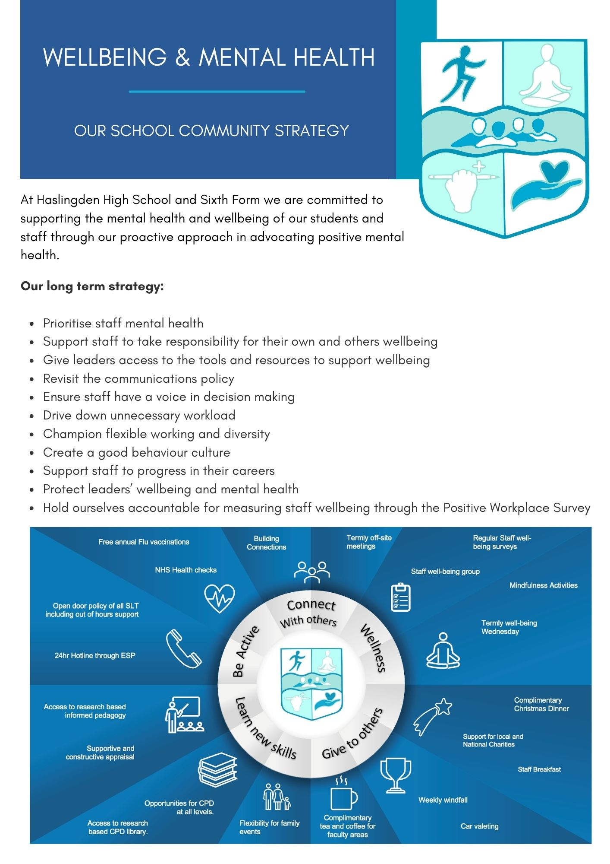

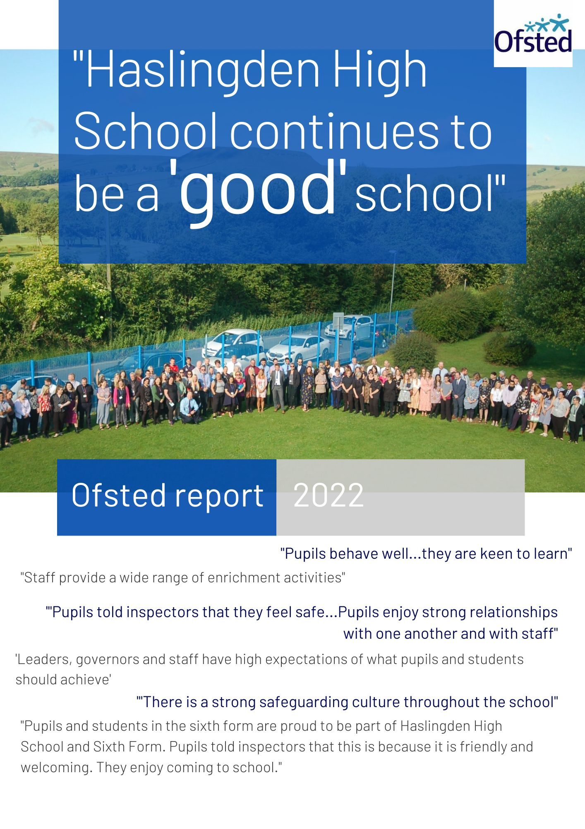
The full inspection report can be viewed here

Thank you for your interest in joining our incredible team of staff here at Haslingden High School and Sixth Form.
Application forms can be found at the bottom of the vacancies section of our website.
Please email your application to applications@haslingdenhigh.com
If you have any questions, please do not hesitate to get in touch.

Haslingden High School and Sixth Form
Broadway, Haslingden, Rossendale, Lancashire, BB4 4EY
01706 215726
www.haslingdenhigh.com
@HaslingdenHigh HaslingdenHigh

