**PENDLE COMMUNITY**

**HIGH SCHOOL & COLLEGE**

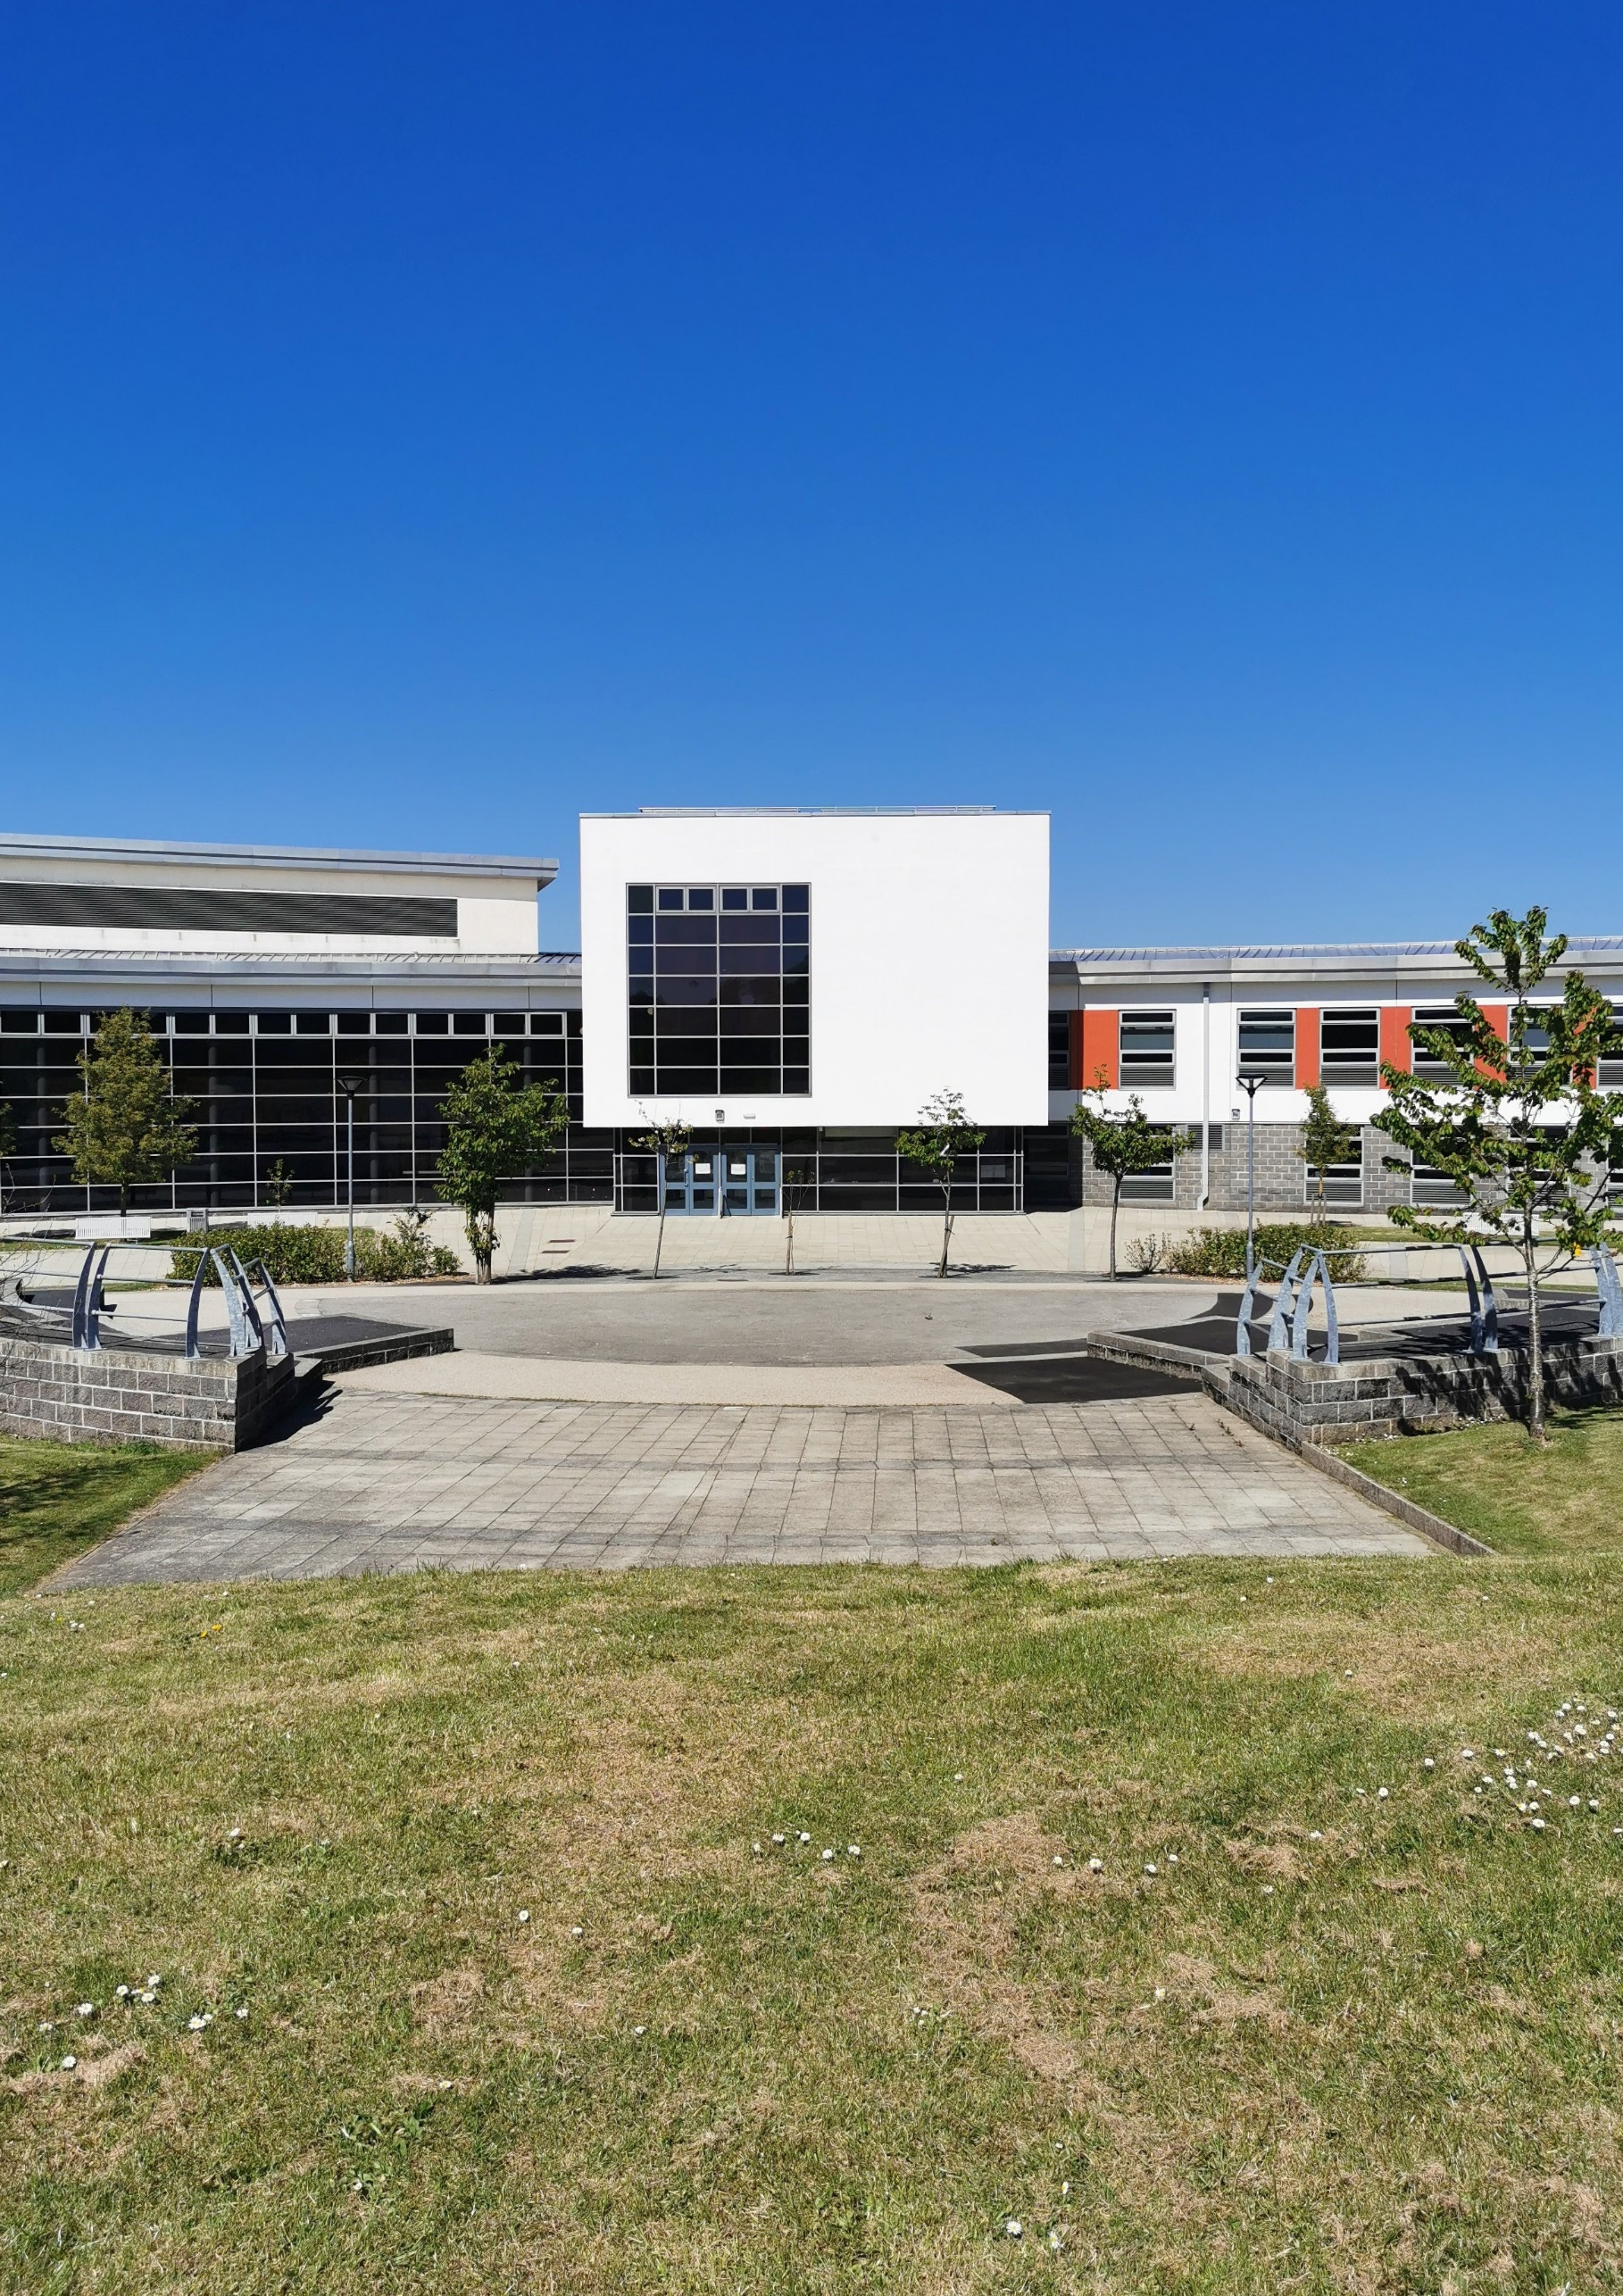

APPLICATION PACK

**WWW.PCHS.LANCS.SCH.UK**

**APPLICATION PACK – OPERATIONS MANAGER**

Pendle Community High School and College (PCHS&C) is an outstanding community special school for students with generic learning difficulties. We currently have 163 students on roll (ages 11 -19), with a variety of special educational needs including autistic spectrum disorders, speech, language and communication needs, and physical, medical and/or sensory needs.

PCHS&C moved into our purpose-built accommodation in 2008, where it is co-located with a mainstream secondary school. Our school and college provide an exciting and enriching environment, with a range of opportunities for social and educational inclusion.

Dear Candidate,

Thank you for requesting more information about the vacancy of **OPERATIONS MANAGER** at Pendle Community High School & College (PCHSC). At PCHSC our core values are at the HEART of everything we do:

1. **H**onesty
2. **E**mbrace diversity
3. **A**mbition
4. **R**espect
5. **T**ogetherness

We are delighted that you have shown an interest in joining our thriving community. If you decide to pursue your application and are successful in securing a job with us, you will be joining a highly committed and dynamic staff team who all play a part in making a real difference to the lives of families, carers and young people with special educational needs.

In addition to this, we also offer a number of staff benefits which includes but is not limited to:

* Enrolment into the Local Government Pension Scheme
* Access to Employee Assistance Program
* Free use of our on-site gym
* Free on-site parking
* Access to the National College and regular CPD opportunities

For more information about our school & college, please visit our website [www.pchs.lancs.sch.uk](http://www.pchs.lancs.sch.uk).

We wish you all the best with your application.



D Grogan, Head Teacher

**IMPORTANT INFORMATION**

**SAFEGUARDING**

In this school, the welfare of the child is paramount. This school is committed to safeguarding and promoting the welfare of children and young people and expects all staff and volunteers to share this commitment.

All staff should understand their responsibility to safeguarding and promoting the welfare of children and young people. Staff are responsible for their own actions and behaviour and should avoid any conduct which would lead any reasonable person to question their motivation and intentions. Staff should work, and be seen to work, in an open and transparent way.

Attitudes towards promoting and safeguarding the welfare of children and young people will be scrutinised during the selection process for the post that you have applied for. If you are appointed to this post, information in relation to safeguarding and protecting children and young people will be provided at induction. This practical guidance for safe working practice will provide information about which behaviours constitute safe practice and which behaviours should be avoided.

The post you are applying for is covered by the Rehabilitation of Offenders (Exceptions) Act 1975. If successful, you will be required to apply to the Disclosure and Barring Service for an enhanced disclosure.

Please note that in line with Keeping Children Safe in Education statutory guidance; an online search will be carried out as part of our due diligence on shortlisted candidates. Please note that if shortlisted, we will seek references **before** you attend the interview.

**EQUAL OPPORTUNITIES**

We are committed to achieving equal opportunities in the way we deliver services to the community and in our employment arrangements. We expect all employees to understand and promote this policy in their work.

**HEALTH & SAFETY**

All employees have a responsibility for their own health and safety and that of others when carrying out their duties and must help us to apply our general statement of health and safety policy. Lancashire County Council operates a smoke and vape free policy on all sites.

**ATTENDANCE**

This school is committed to achieving and maintaining a high level of attendance from all employees through the application of good management practice. The School Leadership Team will monitor overall levels of sickness absences regularly, will support employees during periods of sickness and will arrange for confidential reports to be submitted to Governors. Action will be taken in accordance with the guidelines and procedures adopted by the school to deal with unacceptable levels and frequency of sickness absence. All employees must understand the importance of good attendance and ensure that any sickness absence is kept to a minimum and that during any such absence they do not undertake any activity which is incompatible with the illness or which may delay recovery.

**SUBMITTING YOUR APPLICATION**

Please complete the application form enclosed and submit electronically to Debbie Saxton, HR Administrator, via email at [dsaxton@pchs.lancs.sch.uk](mailto:dsaxton@pchs.lancs.sch.uk).

**OPERATIONS MANAGER – JOB DESCRIPTION**

|  |  |
| --- | --- |
| **JOB TITLE:** | OPERATIONS MANAGER |
| **GRADE:** | 7 SCP 19 - 25 |
| **HOURS | WEEKS** | 37 | Full Year 26 days holiday (32 days after 5 years’ service) per year + bank holidays |
| **CAR USER:** | NA |
| **LOCATION:** | Pendle Community High School & College |
| **RESPONSIBLE TO:** | School Business Manager |
| **STAFF RESPONSIBLE FOR:** | Operational day-to-day management of Admin Team & Site Supervisor |
| **Scope of work – appropriate for this post:** | |
| * To assist the School Business Manager with day-to-day management of the school's operational areas, including facilities, health & safety, catering, external provision. * Role holders at this level will be expected to oversee the day-to-day tasks and activities of a team, and may need to manage budgets if responsible for a large operations team. They must be able to use judgment to deal with daily unforeseen problems, with limited guidance from superiors but within established and known procedures. Roles at this level are typically the first level of supervision or line management in the Council, normally relating to routine support services. They will generally have freedom over practical day to day decision-making within closely defined policies and procedural guidance. | |
| **Accountabilities / Responsibilities – appropriate for this post:** | |
| * Day-to-day management of the schools’ operational areas * Assist the Business Manager in development of strategy in relation to the operational areas managed * Supervise the staff related to the operational areas * Co-ordinate the work of a team to ensure workflow is managed smoothly, that processed are properly implemented & that outputs are accurately recorded. * Assist the Business Manager in performance management of staff * Be responsible for the Health & Safety of the operational areas * Promote & manage the letting of the operational areas * Identify & raise opportunities for improving procedures & processes * Act as a technical reference for the team, monitoring & providing guidance on escalated issues * Train others in the use of equipment, systems or work methods in order to support the development of the team * Manage a small budget, and /or influence decisions about larger budgets to ensure appropriate resources are available to run the team or work area | |
| **Individuals in this role may also:** | |
| * Maximise opportunities for income generation; assist in the preparation of bids for additional funding * Assist with the maintenance of the school website * Assist the Business Manager with any duties at or below this level | |
| **In addition, other duties at the same responsibility level may be interchanged with/added to this list at any time.** | |
| **AGREED BY:** | EPR Team, School Business Manager, Senior Leadership Team |



**OPERATIONS MANAGER – PERSON SPECIFICATION**

|  |  |  |  |
| --- | --- | --- | --- |
| **REQUIREMENTS (based on the job description)** | | **Essential (E) or Desirable (D)** | **Identified by:**  **Application form (A), Interview (I), Test (T), References (R) or**  **other (give details)** |
|  | | | |
| **QUALIFICATIONS** | | | |
| GCSE grade 5 /C English & Maths (or equivalent L2-L3 qual) | | **E** | **A** |
| Business Administration Qualification | | **D** | **A** |
| **EXPERIENCE** | | | |
| Experience of working in a management role | | **E** | **A/I** |
| Experience of working in a school office | | **D** | **A/I** |
| Experience of using bespoke software / packages | | **D** | **A/I** |
| Experience of using Microsoft Office packages | | **E** | **A/I** |
| Experience of supervising staff, including ability to delegate & track performance | | **E** | **A/I** |
| Experience of handling sensitive & confidential information | | **E** | **A/I** |
| **KNOWLEDGE, SKILLS & ABILITIES** | | | |
| Ability to communicate effectively | | **E** | **A/I/R** |
| Ability to work both independently & as part of a team | | **E** | **A/I/R** |
| Ability to work accurately and understand the requirements of GDPR | | **E** | **A/I/R** |
| Ability to prioritise workload to meet strict deadlines | | **E** | **A/I/R** |
| Ability to work under pressure & with conflicting demands | | **E** | **A/I/R** |
| Excellent ICT & organisational skills | | **E** | **A/I/R** |
| Good written & verbal communication skills | | **E** | **A/I/R** |
| **PERSONAL QUALITIES** | | | |
| Reliable & punctual | | **E** | **A/I/R** |
| Enthusiastic, resilient & flexible | | **E** | **A/I/R** |
| High level of professional and personal integrity | | **E** | **A/I/R** |
| Empathy & sensitivity to the needs of staff | | **E** | **A/I/R** |
| **OTHER** (including special requirements) | | | |
| Commitment to undertake training where required | | **E** | **I** |
| Commitment to safeguarding and protecting the welfare of children and young people | | **E** | **I** |
| Commitment to equality and diversity | | **E** | **I** |
| Commitment to health and safety | | **E** | **I** |
| Commitment to attendance at work | | **E** | **I** |
| **Please be aware we will always consider your references before confirming a job offer in writing** | | | |
| **PREPARED BY:** | School Business Manager – June 2025 | | |

**OPERATIONS MANAGER – ROLE PROFILE**

|  |
| --- |
| **AS PART OF THIS ROLE, DUTIES WILL INCLUDE:** |
| Daily line management of admin team & site supervisor including providing cover, dealing with issues as they arise. |
| Operational management of Health & Safety including SLA, risk management, investigate and report on accidents/incidents, COSHH, staff training. |
| Operational management of catering including SLA, menus, staffing, issues and complaints. |
| Point of contact for the administration of transport. Keep the transport list up to date. Deal with any queries / issues. |
| Operational management of facilities including cleaning audits, PFI contracts, lifecycle & maintenance, insurance, new works projects. Attend SPM & facilities meetings and follow up any actions. Maintain the SharePoint system. |
| With input from Finance & ICT Managers, maintain an accurate and up to date asset register |
| Organise MOT, service of minibuses and enter dates into diaries. Organise insurance and file all associated paperwork for the minibus. Organise blue badge renewals |
| EVC support (Assistant co-ordinator). |
| Deal with CCTV requests. |
| Car Park Duty as required. |

|  |  |
| --- | --- |
| **CLOSING DATE:** | Friday 11th July 2025 @ 12 noon |
| **SHORTLISTING DATE:** | Friday 11th July 2025 |
| **PROPOSED INTERVIEW DATE:** | Wednesday 16th July 2025 |