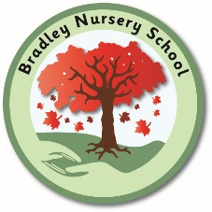

**Bradley Nursery School**

**Nursery School Teaching Assistant (Grade 5: 25183 --- 27269)**

**Full time school positions from September 25)**

We are looking to appoint two knowledgeable, highly motivated Teaching Assistants to join our friendly and welcoming nursery school team.

We are looking for positive, nurturing and reflective practitioners dedicated to ensuring high quality playful teaching both indoors and out.

Candidates must have experience of working within an Early Years Setting with children from 2-4 years and will have a sound working knowledge of the Early Years Foundation Stage Framework. Your experience could relate to the successful completion of Early Years placements linked to a Level 3 training course (as a minimum)

The successful candidates will work within a supportive, experienced school team and as a keyperson and will be fully involved in the teaching, learning and assessment of children in the class. They will be expected to confidently deliver a range of activities and programmes of work to meet the specific needs of individual children and small groups.

Our school is committed to safeguarding and promoting the welfare of children and young people, and expects all staff and volunteers to share this commitment. The post is subject to an enhanced DBS clearance.

For further information about our school please visit [www.bradleynursery.co.uk](http://www.bradleynursery.co.uk)

You are invited to visit our Nursery School and meet our children and staff - please telephone the school office on 01282 615183 to organise an informal chat with the headteacher and to look around our lovely Nursery School.

Application forms are available <https://schooljobs.lancashire.gov.uk> or by contacting our school office (**CVs will not be accepted**)

Completed application forms should be returned to the school by: **12th June** (12noon)

Interviews: Week commencing **23rd June 2025**