**School Business Manager**

**Central Lancaster High School**

Dear applicant

Thank you for your interest in joining the community at Central Lancaster High School. Central Lancaster is part of The Bay Learning Trust, a community of like-minded schools. We serve our community to enable pupils to flourish and achieve excellence. The Trust was established by Ripley St Thomas Church of England Academy in 2017. You can find out more about our Trust by visiting our website:[The Bay Learning Trust](https://www.baylearningtrust.com/)

We are a small and friendly secondary school at the heart of our community. Our core values are Commitment, Creativity and Community. We are looking to recruit a School Business Manager following the retirement of the current post holder. The role is a pivotal one in supporting the key functions of our school in order to support the effective delivery of the curriculum to our pupils.

We were judged ‘good’ in all areas by Ofsted in September 2023. A copy of the report can be read here: <https://reports.ofsted.gov.uk/provider/23/147260>

We have also completed work our £8 million new build which houses five science labs, technology workshops and a catering room alongside a suite of English and maths classrooms.

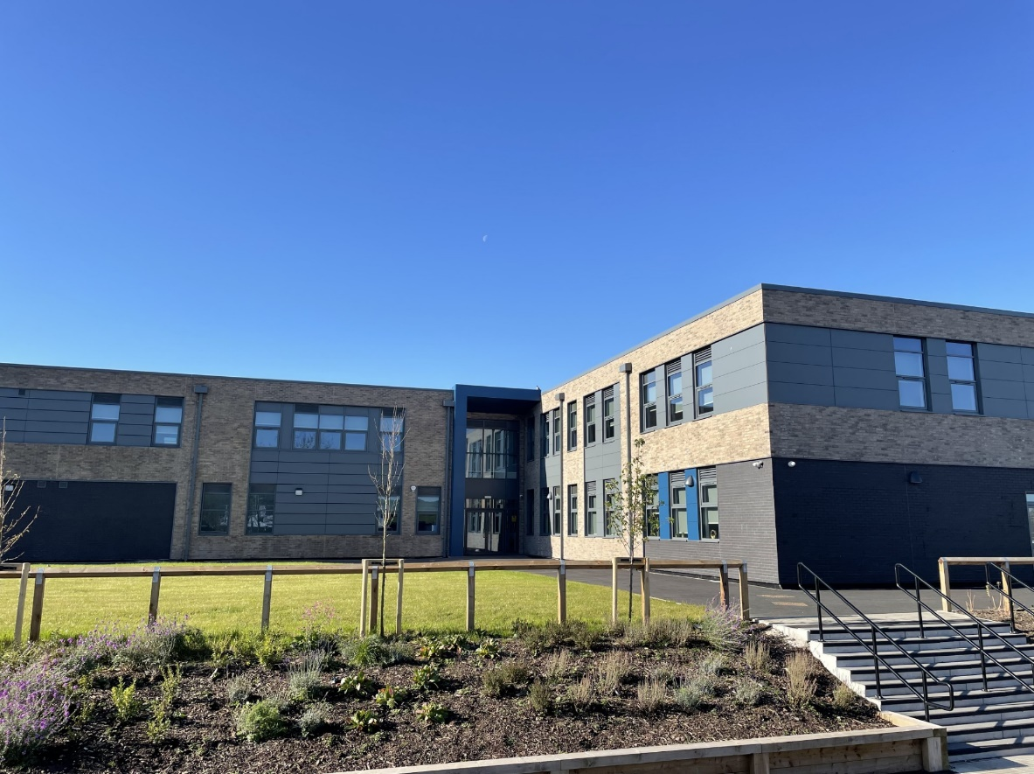

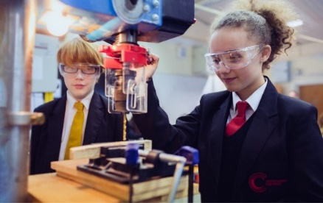

You will have experience of managing the daily functions of a school, specifically in the areas of Finance, School Administration, Catering, Premises, Facilities, ICT and HR and Payroll.

In return we can offer you excellent training and development opportunities across the Trust and a friendly and welcoming staff. If you would like to have an informal, confidential conversation about the role, or to visit our school and speak with our pupils and staff, please contact us on [recruitment@lancasterhigh.lancs.sch.uk](mailto:recruitment@lancasterhigh.lancs.sch.uk)

Yours faithfully

  
Victoria Crossman

Acting Headteacher

Central Lancaster High School