Dear Candidate,

Thank you for showing an interest in the Teaching Assistant position at our school.
We are looking for an enthusiastic, warm and caring team member who will be an asset to our strong Balshaw Lane team. Our school is a lovely place to work with dedicated staff and wonderful children. We value each individual child and we are extremely proud of our “Outstanding” Personal Development. (Ofsted April 2025) Our curriculum is broad, engaging and rich to stimulate the children’s learning.

We require someone who is able to support the teacher, use their own initiative and help cater for the children’s individual needs within the classroom. Previous experience of working with children is essential and knowledge of a classroom environment is desirable. Please see the job description and person specification for more information.
Views to the school are welcomed, please contact the school office to make an appointment.
If you require any further information, please contact the headteacher via email: head@balshawlane.co.uk

Many thanks,
Best wishes,
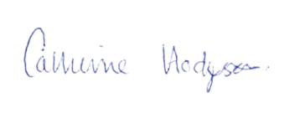
Mrs C Hodgson

