www.leeroydnursery.co.uk

**Lee Royd Nursery School**

**Head teacher**

**-**

**Ms. K. Smith B.Sc. (Hons), PGCE, PG Dip NASENCo**

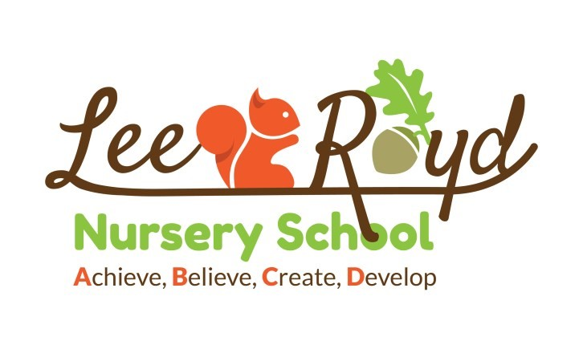

# Teaching Assistant Level 2A – Vacancy

Thank you for your interest in the teaching assistant position in our fantastic Nursery School.

We are looking for an excellent and highly motivated member of staff with high expectations who can engage, inspire and challenge our children. We provide a rich, outstanding environment where high quality adult interactions are essential. Safeguarding is of vital importance to us and we expect all our staff to follow rigid safeguarding procedures and take part fully in all safeguarding training and updates.

The post will be required for 35 hours a week, 8:45am until 4:15pm every day. With one evening till 4:30 for a staff meeting, term time only. The salary quoted is full time equivalent. If successful the salary received will be paid on a pro rata basis.

Please note CVs are not accepted, to apply for this vacancy you need to complete the application form attached and return to head@lee-royd.lancs.sch.uk or deliver to Lee Royd Nursery School, Royds Avenue, Accrington, BB5 2LH.

Closing date: 14/03/2025

Past applicants need not apply.

Please note that in line with Keeping Children Safe in Education 2022, an online search will be carried out as part of our due diligence on shortlisted candidates.

**ADVERTISED POST DETAILS**

Post: Teaching Assistant 2A

Contract: Permanent following an induction period. Term time only

Salary Scale: Grade 4

Annual Salary: £24,404 – £25,183 pro rata

Start Date: ASAP

Closing Date: 12pm Friday 14th March 2025

Proposed Interview: Thursday 20th March 2025

Visit Dates: Please contact the school

**Essential Qualification** – Level 2 DFE Full and Relevant Qualification in Childcare Education and or Equivalent

Other recent/relevant training related to the role.

Informal chats and visits to the school are welcome. Please contact Ms Karen Smith: [head@lee-royd.lancs.sch.uk](mailto:head@lee-royd.lancs.sch.uk) or ring 01254 231725

Application forms should be used and must be returned to Ms Karen Smith, Head teacher, by email:

head@lee-royd.lancs.sch.uk

# Rehabilitation

Rehabilitation The post you are applying for is covered by the Rehabilitation of Offenders Act 1974 (Exceptions) Order 1975 (as amended in 2013). If successful you will be required to apply to the Disclosure and Barring Service (DBS) for a 'disclosure'. Information provided by you or the Disclosure and Barring Service will be dealt with in a confidential manner in accordance with the DBS's Code of Practice. You may view the Code of Practice on the DBS website at www.gov.uk/dbs or alternatively a copy is available on request. Lancashire County Council has a Handling of DBS Certificate Information Policy and a Policy Statement on the Recruitment of Ex-offenders this is available from the recruiting manager to applicants who are asked to complete a DBS application.