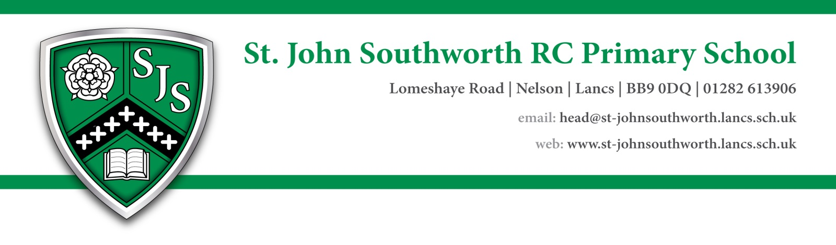

Dear Prospective Applicant

On behalf of the pupils, staff and governors of St John Southworth RC Primary School Nelson may I take this opportunity to welcome you and thank you for your interest in the position of a teaching assistant (Level 2a supporting a small group of children) at our school. St John Southworth serves a diverse community of Nelson and we are very proud of the strong Catholic ethos that lies at the heart of all we do.

St John Southworth is a caring school committed to providing the best possible outcomes for all of our pupils by providing a happy, safe and secure environment where pupils love to learn. On our continued journey of improvement we are looking to appoint a high quality teaching assistant who can inspire, motivate and support our pupils to achieve their full potential.

Further information about our school can be found at [www.**st**-**johnsouthworth**.lancs.sch.uk](http://www.st-johnsouthworth.lancs.sch.uk).

However to get a better understanding of the school we strongly recommend you arrange a visit prior to interview. This can be arranged by contacting the school office on **01282 613906**.

May I thank you for your interest in this vacancy and look forward to receiving your application.

Yours sincerely

Jemma Stuttard

Head teacher