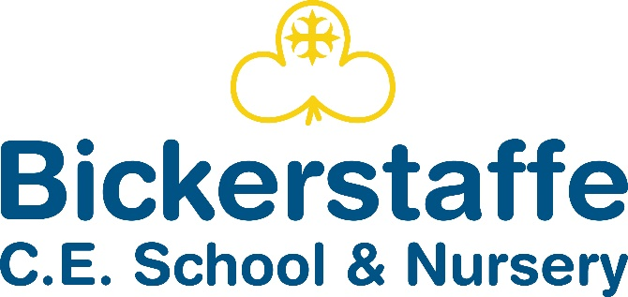

**Hall Lane, Bickerstaffe, Ormskirk, Lancashire, L39 0EH**

**Tel 01695 722957**

# Headteacher – Mrs Carlin

Love each other as I have loved you…

John 15:12

# Job Description

## Teaching Assistant Level 3 (Early Years – Nursery Provision)

Job Title: Teaching Assistant Level 3 (Early Years – Nursery Provision)

Grade: TA3

Location: Bickerstaffe CE School & Nursery

Hours: 32.5 hours per week, term time only

Contract Type: Full time temporary (depending on numbers)

Start Date: 1st September 2025

### Overview:

We are seeking an experienced, passionate, and dedicated Teaching Assistant Level 3 to lead and support the delivery of high-quality early years education in our expanding nursery provision for three-year-olds. This is an exciting opportunity to shape a nurturing, stimulating, and inclusive environment from the ground up, ensuring the best possible outcomes for our youngest learners.

### Key Responsibilities:

* Take a lead role in the planning, delivery, and evaluation of engaging, age-appropriate activities in line with the EYFS framework.
* Provide a warm, caring, and safe learning environment that supports the emotional, physical, and educational development of all children.
* Support the transition and settling-in process for children and families new to nursery provision.
* Observe, assess, and record children's progress and development using appropriate documentation and systems.
* Work collaboratively with the Early Years Lead, SENCO, and other staff to ensure inclusive practices and individualised support.
* Build positive relationships with parents and carers, sharing information and progress regularly.
* Maintain high standards of hygiene, health, and safety, including managing toileting routines and snack/lunchtime support.
* Ensure the indoor and outdoor environments are clean, safe, and well-resourced.
* Support safeguarding procedures and report any concerns in line with school policies.
* Participate in CPD, staff meetings, and training as required.

### Person Specification:

Essential:

* Level 3 qualification in Early Years Education or equivalent (e.g., CACHE Level 3, NVQ Level 3).
* Significant experience working with children in an early years setting, particularly with three-year-olds.
* Thorough understanding of the Early Years Foundation Stage (EYFS) curriculum and child development.
* Ability to plan and lead engaging, play-based learning experiences.
* Excellent communication skills with children, parents, and colleagues.
* Commitment to safeguarding, inclusion, and promoting the welfare of all pupils.

Desirable:

* Paediatric First Aid certificate.
* Knowledge or experience of working with children with SEND.
* Experience in setting up or contributing to a new nursery or provision.
* Experience using online learning journals or assessment tools (e.g., Tapestry, Learning Book).

Application Deadline: 14th June at 12:00 p.m.

Interview Date: Monday 23rd June

To Apply: Please complete attached application and return to head@bickerstaffe.lancs.sch.uk