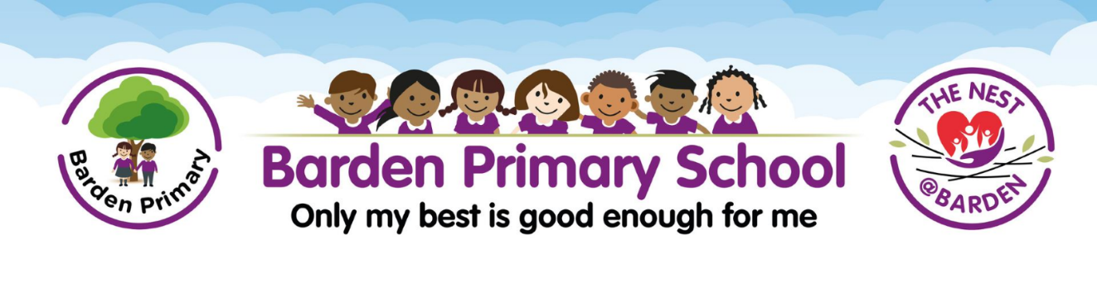

**Barden Primary School Business Manager 3 (Grade 10)**

**37 Hours a week**

**Permanent**

**Full Time (holidays to be taken out of term time)**

**Following a re-design of our school office structure, an exciting, brand-new opportunity for a School Business Manager has been created. This role is not just about managing finances; it is about shaping the foundation of our school's future. The successful applicant would be a key member of our Senior Leadership Team and play a crucial role in shaping the strategic direction and operational effectiveness of our wonderful school. Ultimately, our new School Business Manager will help steer our school towards greater achievements and sustainable growth, ensuring that every child receives the best possible education.**

**The grade attached to the post is higher than would usually be allocated to this role in a primary setting and reflects that we are based within a Private Finance Initiative setting (PFI). As a result of this, there are further considerations and more complexities than in a local authority-maintained school, such as managing the PFI contract for the school. Prior knowledge or experience of the workings of a PFI setting is not an essential requirement for applicants and support and training will be provided for the successful applicant. Likewise, we appreciate that to appoint the very best candidate, experience of working in a school setting is not essential and training will be provided if required.**

**About us**

**Barden is a large, 2 form entry primary school with a Special Educational Needs Unit (The Nest @ Barden). The school was built as part of the Building Schools for the Future (BSF) initiative and is a PFI school. We are based on Burnley Campus, which is an amazing resource with outstanding facilities, such as separate spacious indoor and outdoor sports facilities, lecture theatres and auditoriums, a community library and The Faith Centre all on site. To see more of our fantastic school, please have a look at our new school website and view our fantastic virtual tour.**

<https://www.barden.lancs.sch.uk/page/?title=360%27+Tour&pid=18>

The successful candidate will be joining Barden Primary School at an exciting time, as we continue to build on our successes and move forward on our journey. We are looking for a committed and enthusiastic individual who will;

* Be a passionate, caring and inspirational member of our team
* Be self-motivated and reliable
* Have high expectations of themselves and others
* Be an excellent communicator committed to being part of an effective team within the whole school community
* Have the ability to form warm and positive relationships with pupils, staff and parents
* Be committed to Continuous Professional Development
* Be committed to the ethos of the school through our vision and values.

**We can offer**

* A motivated, hardworking and supportive team, who are committed to offering the best opportunities for all children
* A commitment to you and your professional development
* Strong, supportive leadership and a caring and enthusiastic staff team
* Enthusiastic, well-motivated pupils and supportive parents
* Encouragement and trust to develop your own ideas
* The opportunity to achieve and experience success in a motivating, exciting and forward-thinking school.

**School visit strongly advised** Choosing a school to work in is a significant life event. It is important that this decision is right for both you and the school. As such, we stronglyrecommend that you come to visit our wonderful school before applying. Please call our friendly school office on 01282 226777 to book your place.

**School tours will take place on:**

* Friday 2nd May – 1:30pm
* Tuesday 6th May - 4:00pm

**Other dates:**

|  |  |
| --- | --- |
| **Closing Date** | Wednesday 14th May @ (midnight) |
| **Shortlisting** | Thursday 15th May |
| **Interview** | Wednesday 21st May and Thursday 22nd May |
| **Start Date** | 1st Sep 2025 |

**Equal opportunities**

We are committed to achieving equal opportunities in the way we deliver services to the community and in our employment arrangements. We expect all employees to understand and promote this policy in their work.

**Health and safety**

All employees have a responsibility for their own health and safety and that of others when carrying out their duties and must help us to apply our general statement of health and safety policy.

**Safeguarding Commitment**

This school is committed to safeguarding and protecting the welfare of children and young people and expects all staff and volunteers to share this commitment. Please note that in line with Keeping Children Safe in Education 2023, an online search will be carried out as part of our due diligence on shortlisted candidates.