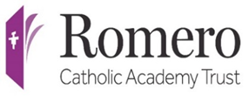 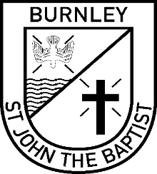

**ST JOHN THE BAPTIST RC PRIMARY SCHOOL**

Diocese of Salford

*Required to commence as soon as possible*

**Job title:** School **Business Support Officer**

**Grade:**  **Grade 3, Point 3 £ 24 310-£24 404 (£18 055- £18 125 Pro-rata / actual)**

**Working Pattern: 32.5 hours per week; Monday to Friday 8.30am to 3.30pm (30 mins**

**unpaid lunch)**

**Term-time only**

St John the Baptist RC Primary School is part of the Romero Catholic Academy Trust and is a Catholic school where the message of Christ inspires the curriculum and all aspects of school life.

The Directors of the Romero Catholic Academy Trust and Governors of St John the Baptist RC Primary School wish to appoint an energetic, well-motivated Business Support Officer to join their existing school office team. This is a fantastic opportunity for somebody wishing to develop their skills by undertaking a in a supportive, vibrant school. There will also be the requirement to undertake a lunchtime duty, which will involve supervising and assisting pupils during lunchtime to ensure that a safe and positive learning environment is maintained and that all children behave in an appropriate manner, really giving the successful candidate a rounded school-life experience.

We are looking for someone who:

* is confident in dealing with a diverse range of people
* has excellent communication skills
* has good time management
* can maintain professionalism and confidentiality in all situations
* has the ability to deal with sensitive matters with a caring manner
* is a committed team player

We can offer you: -

* The opportunity to be part of a friendly, supportive team
* A comprehensive training and development programme
* Local Government Pension Scheme
* Employee Assistance Wellbeing Support Service

If you feel you have the skills required, we look forward to hearing from you. If you would like to find out more about the position please contact Ann Marie Darwin , School Business Manager on 01282 438120 or office@stjohns.lancs.sch.uk.

**Full details and application forms are available from our website:**

[https://www.stjohnsrcprimary.uk](https://www.stjohnsrcprimary.uk/)

*St John the Baptist is committed to safeguarding and promoting the welfare of children and an enhanced DBS disclosure will be required.*

**Closing date: Friday 29th August 2025**

**Interview Date: Friday 12th September 2025**