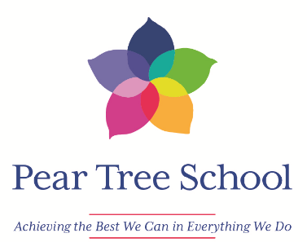

Dear Applicant,

Thank you for your interest in the post of Teaching Assistant 1 at Pear Tree School. Pear Tree is an outstanding school for children and young people aged 4-19 years with severe and profound and multiple learning difficulties. There are currently 113 pupils on role.

The successful candidate will share our vision and values and work collaboratively with the school team in meeting the physical, sensory, personal, social and curriculum related needs of all pupils and establish positive relationships.

A willingness to support the out of school learning of children and young people attending Pear Tree Holiday Club is essential.

Pear Tree is a highly successful special school with very strong links in the community. Having achieved Investors in People Gold Award and actively investing in staff well-being, we are committed to supporting all of our staff to **“achieve the best they can in everything they do”.**

We are committed to safeguarding children and young people and expect staff to share this commitment.

The closing date for all applications is on Thursday 25th September 2025 at noon and the proposed interview date is Friday 3rd October 2025.

We are proud of our school and we welcome your interest in this post.

Yours faithfully,

Fiona Wafer

School Business Manager