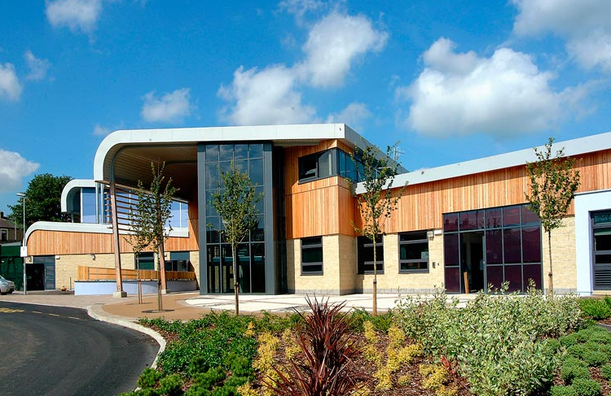

21 June 2024

The Rose School
  - Candidate Information pack

Teaching Assistant 2

  - Document Control

Information
Creation date | 21/06/2024
Recruitment Lead for post | Darren Perry
Recruitment Lead contact email | Darren.perry@rose.lancs.sch.uk
Template version | Candidate Information pack | TA2
Category | Recruitment
Role | Teaching Assistant 2
Closing Date | 05 July 2024
Hours | 27.5 hours per week Term Time only
Interview Date | TBC
Start Date | ASAP
Salary Grade | Grade 5 depending on experience against the job spec

The Rose School
Greenock Street
Burnley
BB11 4DT
Tele: 01282 683050
Table of Contents
Introduction to the role 4
About the school 4
Personal Specification 6
Job Description 7
School Ethos 7
Additional Information 9
Equal opportunities 9
Health and safety 9
Safeguarding Commitment 9
Customer Focus 9
Skills Pledge 9
Disclosure and Barring Service (DBS) 9
References 9
Online Search 9
Applying 9

Introduction to the role
Do you want to work in a unique SEN school where your support will make a real difference to pupils’ lives and ambitions for their future?

We are looking for an outstanding, enthusiastic and forward-thinking teaching assistants to work with all our pupils. The contract will be a variable hours contract, minimum 16 hours to a maximum of 37, starting at 27.5hrs per week 8:30am to 2:00pm Monday to Friday with 1/2 hour unpaid lunch.
Good communication skills are crucial in liaising with students, staff, parents/guardians, and
professionals.

The successful candidate must demonstrate effective use of behaviour management strategies and be
able to work using their own initiative while following policies and procedures. The successful candidate
must be confident in team teach and be strong at de-escalation strategies.

For more information about the school please visit our website www.theroseschoolburnley.co.uk.
Please read the job description and person specification contained within this document carefully.
For more information on the role, please speak to the recruitment lead for this post Head of School Darren Perry.

The Rose School is an equal opportunities employer and is committed to safeguarding and promoting the welfare of children and young people. The successful applicant will be subject to an enhanced DBS check.

The post you are applying for is covered by the Rehabilitation of Offenders (Exceptions) Act 1975. If
successful you will be required to apply to the Disclosure and Barring Service for a 'disclosure'.

Rehabilitation of offenders Act 1974 - details of any criminal record spent or unspent should be sent to
the Chair of Governors at the school address by the closing date.

Completed applications must be submitted electronically to: sbm@rose.lancs.sch.uk

Thank you for your interest in the role and we look forward to hearing from you soon.

Clare Chamberlain
School Business Manager

About the school

Who Are We?
The Rose School is a Secondary Special Day School in East Lancashire. The Rose School is a small school that welcomes young people who face social, emotional and mental health challenges. All pupils have an EHCP for SEMH or ASD. We provide a safe, caring and supportive environment where each child’s progress is central to our aims and purpose. We provide specialist support and guide each pupil on their individual journey, using rewards and consequences to encourage pupils towards greater responsibility and positive choices.

What Do We Do?
Here at The Rose we believe that all our pupils are unique, special and deserving of the best education we can provide. We unearth their uniqueness and enrich it with education, allowing them to flourish on the next step of their journey.
We offer a range of subjects and other opportunities that allow pupils to find what excites and inspires them, creating a lifelong interest in learning. Activities promoting independence, responsibility and leadership help to uncover strengths, which the pupils can use in the pursuit of success. Achievement may be academic or vocational or about personal growth, but it always begins with a pupil unearthing their unique potential.

Why Do We Do It?
Every member of staff who works at The Rose School believes in the young people we support. We listen and encourage each child to be their own guide along the route to success. We know that pupils learn best when they feel safe, nurtured and listened to in an environment that offers creativity alongside stability and routine. Our broad curriculum is relevant, rewarding and prepares pupils for adult life.
Pupils achieve more when they have a sense of well-being and belonging. Our school pays individual attention to each pupil to ensure they find their own way by accessing appropriate learning opportunities and receiving individual support.

Personal Specification
Post Title | Teaching Assistant 2
Grade | 3
Personal Attributes required (based on the | Essential (E)  Or  Desirable | To be identified by: (eg application form (AF), interview (I), reference (R).
Job Description)
Qualifications  NVQ level 2 or above qualification –appropriate to the post (or equivalent)  Level 2 or equivalent qualification in  English/Literacy and Mathematics/Numeracy | D  D | A  A
Experience  Experience of working with or caring for children of relevant age  Experience of working in a relevant classroom/service environment Experience of Administrative work  Experience of supporting pupils with challenging behaviour | E  D  D | A, I  A, I  A, I
Knowledge/skills/abilities  Ability to operate at a level of understanding and competence equivalent to NVQ Level 2 standard | E | A, I
Ability to relate well to children | E | A, I
Ability to work as part of a team | E | A, I
Good communication skills | E | A, I
Ability to supervise and assist pupils  Time management skills  Organisational skills  Knowledge of classroom roles and responsibilities  Knowledge of the concept of confidentiality  First Aid/Paediatric First Aid Certificate  Administrative skills  Knowledge of Early Years Foundation Stage  Good numeracy and literacy skills  Ability to make effective use of ICT  Flexible attitude to work | E  D  D  D  E  D  D  D  E  D  E | A, I  A, I  A, I  A, I  A, I  A  A, I  A, I  A  A, I  A, I
Other  Commitment to undertake in –service development Commitment to safeguarding and protecting the welfare of children and young people | E  E | A  A, I

Job Description
In addition to the following duties, the postholder may be required to undertake any of the duties normally associated with a lower graded Teaching Assistant post

Accountabilities/Responsibilities – appropriate for this post:
Support for Pupils
- Under the general supervision and direction of the teacher to implement structured learning activities for individuals and groups of pupils.
- To undertake activities in order to monitor the personal social and emotional needs of pupils.
- To develop positive relationships with pupils to promote pupil progress and attainment.
- To assist in the devising of pupil's individual targets and their monitoring and review.
- Support pupils as part of a planned inclusion programme
- To implement specific programmes with individual pupils or groups appropriate to the developmental needs of individual children throughout different curriculum areas.
- To assist in the development of varying skills that support pupils' learning.
- To assist in the specific medical/care needs of pupils when specific training has been undertaken. In a special school, this may include complex medical needs.

Support for the Teacher
- To monitor and record pupil progress and developmental needs.
- To produce relevant classroom resources.
- To undertake classroom administrative tasks including the maintenance of records.
- To assist in pupil supervision and assist in the management of pupil behaviour.
- To provide short term cover for classes to which the Teaching Assistant is normally assigned, when the class teacher is unexpectedly unavailable.
- To provide information to the class teacher to assist in the planning of work programmes.
- To liaise with the school's nominated person in respect of pupil absence.
- To assist with the arrangements for out of school learning activities including the administration of work experience.
- To provide clerical and administrative support including the collection and recording of money.
- Administer routine tests, assist in the invigilation of exams and undertake routine marking of pupils work

School Ethos
- Play a full part in the life of the school community, supporting its distinctive mission and ethos and encouraging staff and students to follow this example.
- Promote actively the school’s corporate policies.
- Comply with the school’s health and safety policy and undertake risk assessments as appropriate

The school will endeavour to make any necessary reasonable adjustments to the job and the working environment to enable access to employment opportunities for disabled job applicants or continued employment for any employee who develops a disabling condition. This job description is current at the date below but will be reviewed on an annual basis and, following consultation with you, may be changed to reflect or anticipate changes in the job requirements which are commensurate with the job title and grade.

Support for the School
- To assist in providing an atmosphere in which effective learning can take place.
- To support the promotion of positive relationships with parents, carers and outside agencies.
- To work within school policies and procedures.
- To attend staff training as appropriate.
- To take care for their own and other people's health and safety.
- To be aware of the confidential nature of issues related to home/pupil/teacher/school work.

Support for the Curriculum
- To assist the delivery of educational and developmental work programmes.
- To support the use of ICT in learning activities

Additional Information
The above document sets out the area of work in which duties will generally be focused and gives an example of the type of duties that the postholder could be asked to carry out. PLEASE NOTE that this is for guidance only. Postholders are expected to be flexible and to operate in different areas of work/carry out different duties as required.

Equal opportunities
We are committed to achieving equal opportunities in the way we deliver services to the community and in our employment arrangements. We expect all employees to understand and promote this policy in their work.

Health and safety
All employees have a responsibility for their own health and safety and that of others when carrying out their duties and must co-operate with us to apply our general statement of health and safety policy.

Safeguarding Commitment
We are committed to protecting and promoting the welfare of children, young people and vulnerable adults.

Customer Focus
We put our customers’ needs and expectations at the heart of all that we do. We expect our employees to have a full understanding of those needs and expectations so that we can provide high quality, appropriate services at all times.

Skills Pledge
We are committed to developing the skills of our workforce.

Disclosure and Barring Service (DBS)
The Rose School is an equal opportunities employer and is committed to safeguarding and promoting the welfare of children and young people. The successful applicant will be subject to an enhanced DBS check. The post you are applying for is covered by the Rehabilitation of Offenders (Exceptions) Act 1975. If successful you will be required to apply to the Disclosure and Barring Service for a 'disclosure'.

References
At least two references are requested for each shortlisted applicant, one of which must be the current or most recent employer. If the applicant is not currently working with children, but has done so in the past, a third reference maybe sought from the employer for whom the candidate was most recently employed to work with children. We will always consider your references before confirming a job offer in writing.

Online Search
As part of the statutory guidance for Keeping Children Safe in Education (KCSIE) guidance, an online search will be carried out on shortlisted candidates. This may help identify any incidents or issues that have happened and are publicly available online in respect to Keeping Children Safe in education only. Applicants may be questioned at interview on any matters arising.

Applying
Completed applications must be submitted electronically to: sbm@rose.lancs.sch.uk

