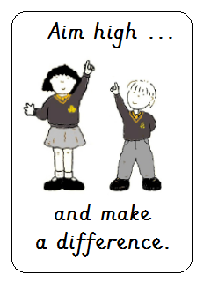

Beaufort Road, Morecambe, LA4 6UB
(01524) 416971
office@greatwood.lancs.sch.uk
head@greatwood.lancs.sch.uk

Job Description – Teaching Assistant Level 2b (Grade 5)
Main Activities

- Working with school systems to safeguard children
- Developing positive relationships with children, staff and parents
- Supporting teaching and learning of individuals, groups and whole class
- Supporting children with SEND and / or challenging behaviour
- Contribute to and evaluate children’s action plans linked to SEND and / or behaviour
- Using positive behaviour management strategies consistently
- Implementing and adapting learning activities / programmes for individuals and groups
- Promote good progress in continuous provision and in phonics and early reading when in EYFS and KS1
- Providing immediate and purposeful feedback to children to support learning
- Monitoring and recording pupil progress, including formal assessments
- Use ICT effectively to support teaching and learning
- Creating relevant classroom resources to support teaching and learning
- Contributing to a supportive and nurturing learning environment
- Following appropriate training, supporting children’s medical / health needs
- Providing short term cover for a class when the teacher is absent from the room
- Administer First Aid, when trained, to pupils following school procedures
- Follow the school’s confidentiality, safeguarding and health & safety policies
- Have a flexible, positive and hardworking attitude to work
- Using your initiative, work independently to prioritise and complete tasks
- Work effectively and collaboratively with others in different teams
- Maintain high levels of integrity and confidentiality

Continuing Professional Development
- Identify and attend relevant CPD and implement relevant strategies
- Respond positively to and implement as necessary any feedback from colleagues
Other
- Commitment to take an active part in the wider life of the school
- Willing to share personal skills and talents with the school
- Commitment to welfare and other roles depending on the needs of the school
- Excellent health, attendance and punctuality
- Neat, tidy and professional appearance

