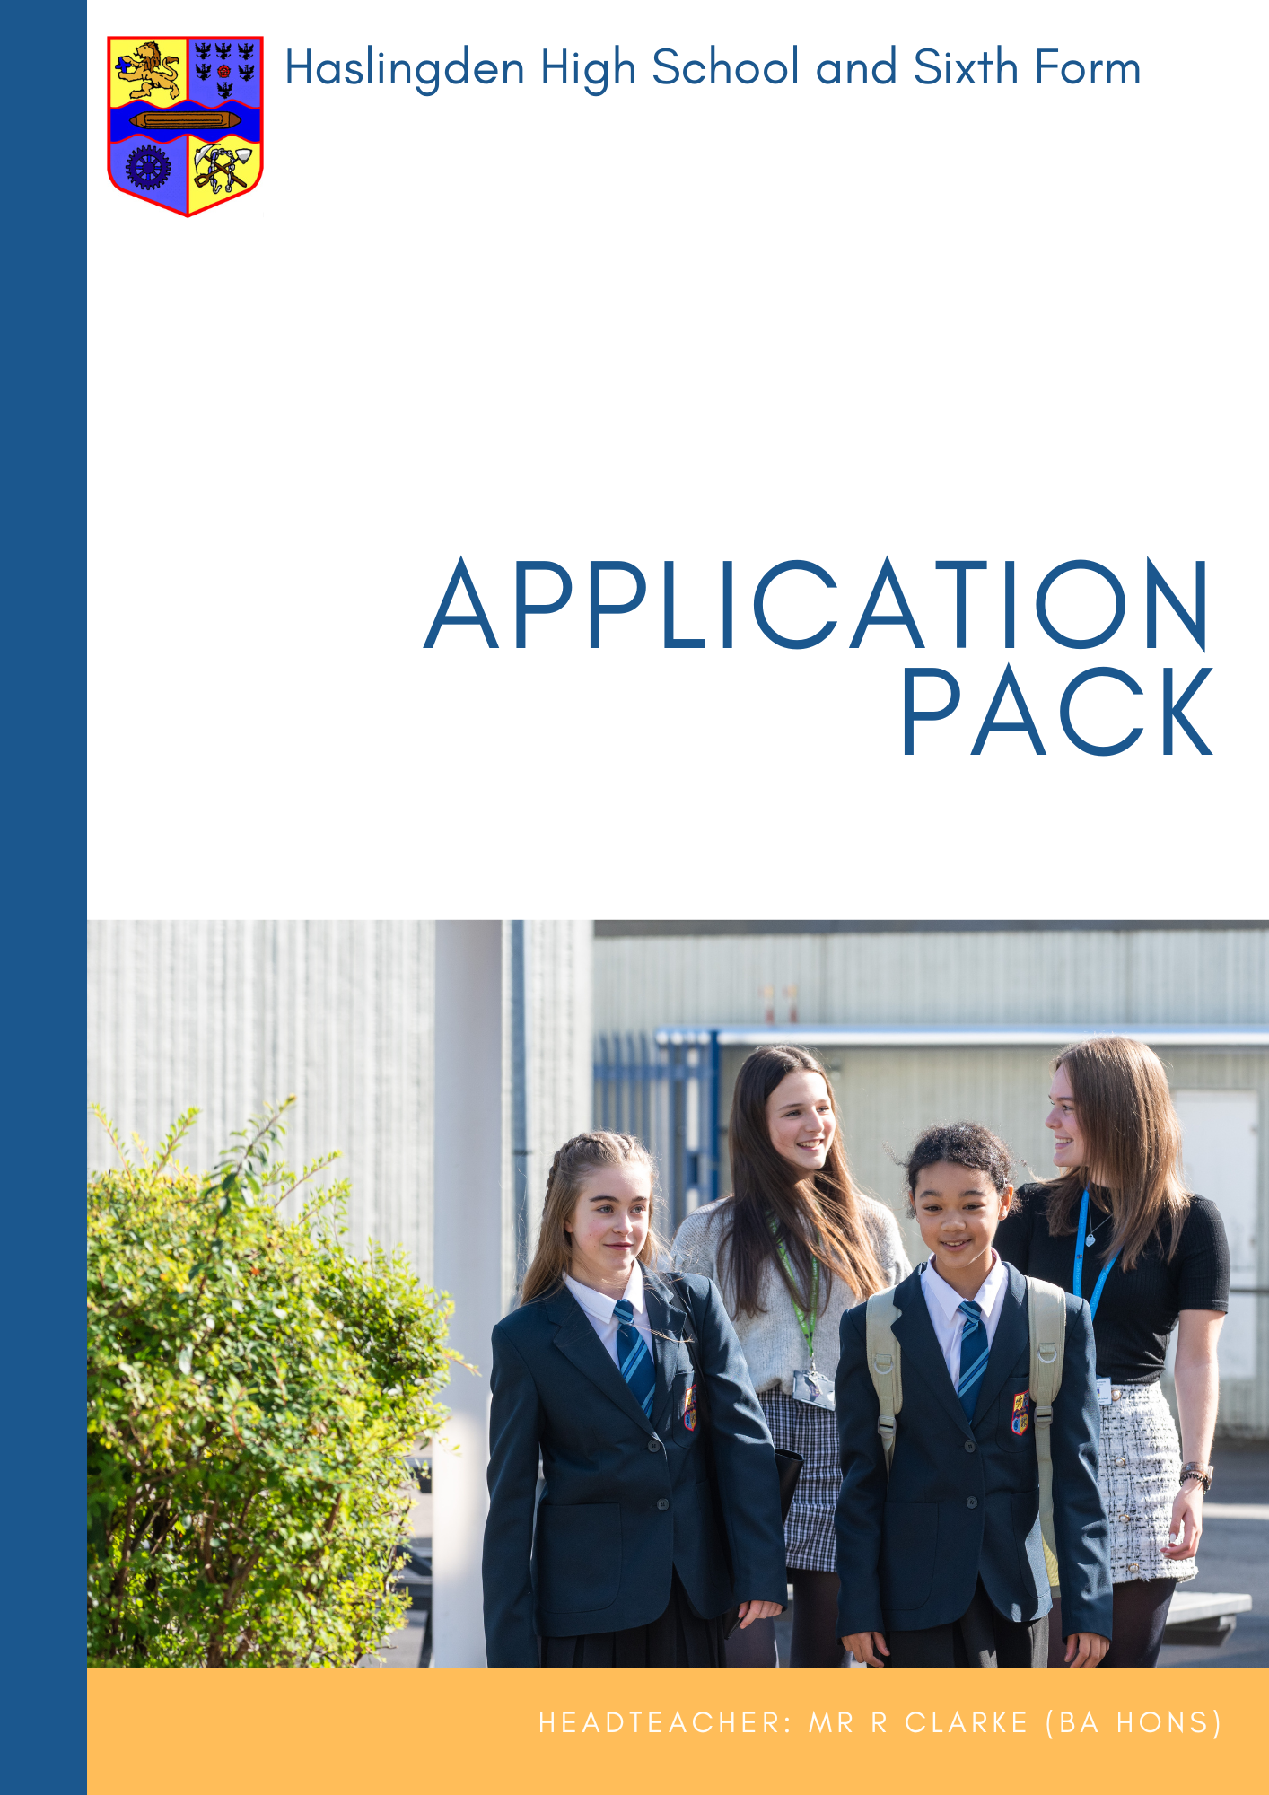
A
Cleaner


Closing date for applications: Monday 3 November 2025
Interviews will take place during w/c 10 November 2025
Grade 2, Point 2
Annual full time salary: £24,413
Hourly rate: £12.65
Part time: morning and afternoon shifts available: (6.30am – 8.30am) (1.30pm – 5.00pm)
Term-time only + 3 weeks during the summer holidays

We are currently seeking to appoint a hardworking, committed and enthusiastic individuals to work within our in-house cleaning team. We are looking for people who enjoy working as part of a team and pride themselves on a high standard of work. A sense of humour, a smile and empathy for young people and colleagues are all essential characteristics needed to be successful in this post. If this sounds like you, we look forward to reading your application.

Cleaning is undertaken during the early morning before school starts, and during the afternoons until 5/5.30pm. Please indicate your availability in your application. Please note that only fully completed application forms can be considered.

Further details and an application form are available on our web site: www.haslingdenhigh.com/vacancies

Haslingden High School & Sixth Form is committed to safeguarding and promoting the welfare of children and young people and takes its statutory duties and responsibilities in this context very seriously. We fully expect everyone working in or behalf of the school to share our commitment. As such, this post is subject to satisfactory DBS clearance and references.

Cleaner
Required from ASAP
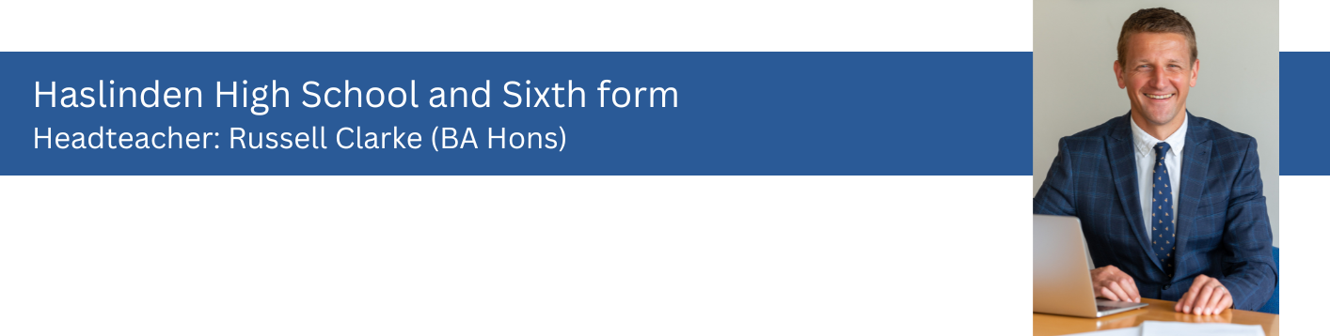
Haslingden High School and Sixth Form
Headteacher: Russell Clarke (BA Hons)

Dear Applicant,

Thank you for your interest in the post of Cleaner at Haslingden High School and Sixth Form.

The Governors are seeking to appoint enthusiastic, skilled and dedicated Cleaners to support the school’s drive towards ‘Achievement for All’. The successful candidates should have experience against the job description accompanied by a successful track record.

Haslingden High School and Sixth Form is a high performing school and has an excellent reputation both locally and beyond. The school is significantly oversubscribed for the 270 places available annually in Year 7. We have wonderful students who are proud to be part of our school; a committed, talented staff and excellent facilities. We can look to the future, however uncertain it currently appears nationally, with confidence. We were inspected by Ofsted in May 2022 and they acknowledged the many significant strengths of the school in what is a very pleasing report, rating it as good.

Our GCSE results have been consistently strong in recent years. Our students performed exceptionally well given the challenges that they have faced and we remain very proud of all we have achieved together as a school community. We have a successful sixth form where students make strong progress and many of them choose to go on to university, the vast majority at their first choice of establishment.

In order for our school to operate in a smooth and effective manner, we know that we need the support of all colleagues and teams. We are very fortunate that our support staff are a highly effective and hardworking team who underpin all the great work that we do.

Haslingden High School and Sixth Form seeks to provide an outstanding holistic education for our students. Whilst achieving fantastic examination results is one of our core aims, our remit is much wider. We endeavour to equip all our students with the skills for further study and the world of work; provide them with the tools to develop their own set of values and beliefs conducive to being a good citizen; and provide an extensive range of extra-curricular activities for students to develop their own interests and aptitudes.

The successful applicant will find caring, friendly and supportive colleagues, committed to providing the very best life chances for all our students. We look forward to receiving your completed application form outlining your skills and experience. The closing date for applications Monday 3 November at 9.00 am with interviews to take place during week commencing 10 November 2025.

Haslingden High School and Sixth Form is committed to safeguarding and promoting the welfare of children and young people and takes its statutory duties and responsibilities in this context very seriously. We fully expect everyone working in or on behalf of the school to share our commitment. As such, this post is subject to satisfactory enhanced DBS clearance and references.


Yours sincerely

Mr R Clarke
Headteacher

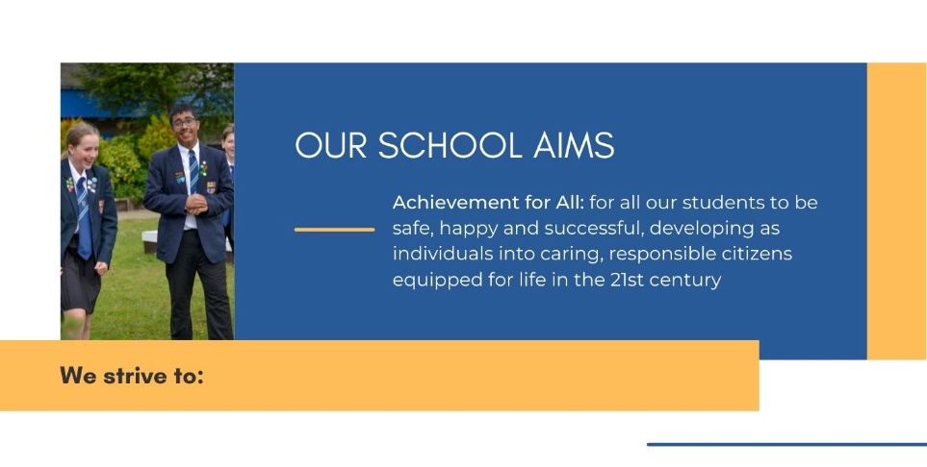

- Create successful learners, who achieve the best possible qualifications, alongside equipping them with the skills and motivation to overcome future challenges

- Ensure all students experience an exciting, ambitious and inclusive curriculum that is well-planned, broad, diverse and expertly delivered. Our curriculum will inspire and motivate all students to want to know and remember more, allowing them to become lifelong learners

- Provide access to a wide range of opportunities and experiences beyond the taught curriculum, enabling all our students to leave our school with high aspirations

- Work in partnership to offer a personalised approach to care, guidance and support that will ensure all students feel and know how to keep themselves safe and happy. Students’ physical, mental and emotional wellbeing is at the forefront of everything we do, empowering them to make informed choices

- Guide students, helping them to become kind, resilient and ethical individuals who will make a positive contribution to their local community and beyond. They will embrace change and leave as well-rounded individuals with a strong set of values and beliefs



POST TITLE: | Cleaner
GRADE: | Grade 2
CAR USER: | No
LOCATION: | Haslingden High School & Sixth Form
RESPONSIBLE TO: | Cleaning Manager
STAFF RESPONSIBLE FOR: | None
JOB PURPOSE: The main objectives to be achieved by the Postholder
Under the direction and instruction of the Cleaning Manager, to undertake the cleaning of designated areas within the School premises to ensure that they are kept in a clean and hygienic condition, to the agreed quality standards.
MAIN What the Postholder will actually do
ACTIVITIES What prescribed duties the postholder will have
Cleaning
- Cleaning including closure cleaning;
- Sweeping, vacuum cleaning and mopping of floors;
- Emptying litter bins;
- Polishing and dusting of surfaces and fixtures and fittings;
- Cleaning of changing rooms, toilets and shower facilities, including replenishment of paper towels, toilet rolls and other disposables;
- Using appropriate powered equipment e.g. floor buffer;
- To notify line management or other Senior member of staff, of any damage to buildings and equipment or anything you see that may be dangerous to pupils or staff;
- To inform Site Staff of matters requiring attention e.g. light bulb replacement, blocked toilets etc;
- To inform Cleaning Manager when there is low stock of cleaning materials and other disposables etc;
- To undertake training in the correct use of cleaning equipment as appropriate;
- Additional cleaning for one-off occasions i.e. Open Evenings, Visits etc.
General
- At all times to carry out the duties in accordance with school-based policies and Health and Safety procedures;
- To participate in the School’s appraisal scheme where appropriate;
- The duties may be varied by the Headteacher and/or Governing Body to meet changed circumstances in a manner compatible with the post held.

Note: In addition, other duties at the same responsibility level may be interchanged with/added to this list at any time

Equal opportunities
We are committed to achieving equal opportunities in the way we deliver services to the community and in our employment arrangements. We expect all employees to understand and promote this policy in their work.
Health and safety
All employees have a responsibility for their own health and safety and that of others when carrying out their duties and must co-operate with us to apply our general statement of health and safety policy.

Customer Focus

We put our customers’ needs and expectations at the heart of all that we do. We expect our employees to have a full understanding of those needs and expectations so that we can provide high quality, appropriate services at all times.

Skills Pledge

We are committed to developing the skills of our workforce. All employees will be supported to work towards a level 2 qualification in literacy and /or numeracy if they do not have one already.

Attendance

Good attendance enhances the service delivered by schools, minimises staffing difficulties and ensures best value to the school. It is essential that applicants for positions in this school can evidence a previous satisfactory attendance record/commitment to sustaining regular attendance at work.



Cleaner

 | Essential | Desirable
Application form and/or letter
Knowledge, experience and abilities:
- Experience of working as a cleaner
- Experience of using powered equipment (e.g. floor buffer)
- Ability to work as part of a team
- Flexible attitude to work
- Ability to work in an organised and methodical way
- Awareness of Health & Safety issues
- Awareness of CoSHH
- Good interpersonal skills
- Positive approach to customer care and service delivery
- Commitment to undertaking relevant training and development

Interview and/or letter

Other (including special requirements)
- Commitment to safeguarding and protecting the welfare of children and young people
- Commitment to equality and diversity
- Commitment to health and safety
- Willingness to work occasionally outside of contracted hours (e.g. Parents evenings, lettings etc)
- Satisfactory attendance record/commitment to regular attendance at work
Application form
The application form should be fully completed and accurate

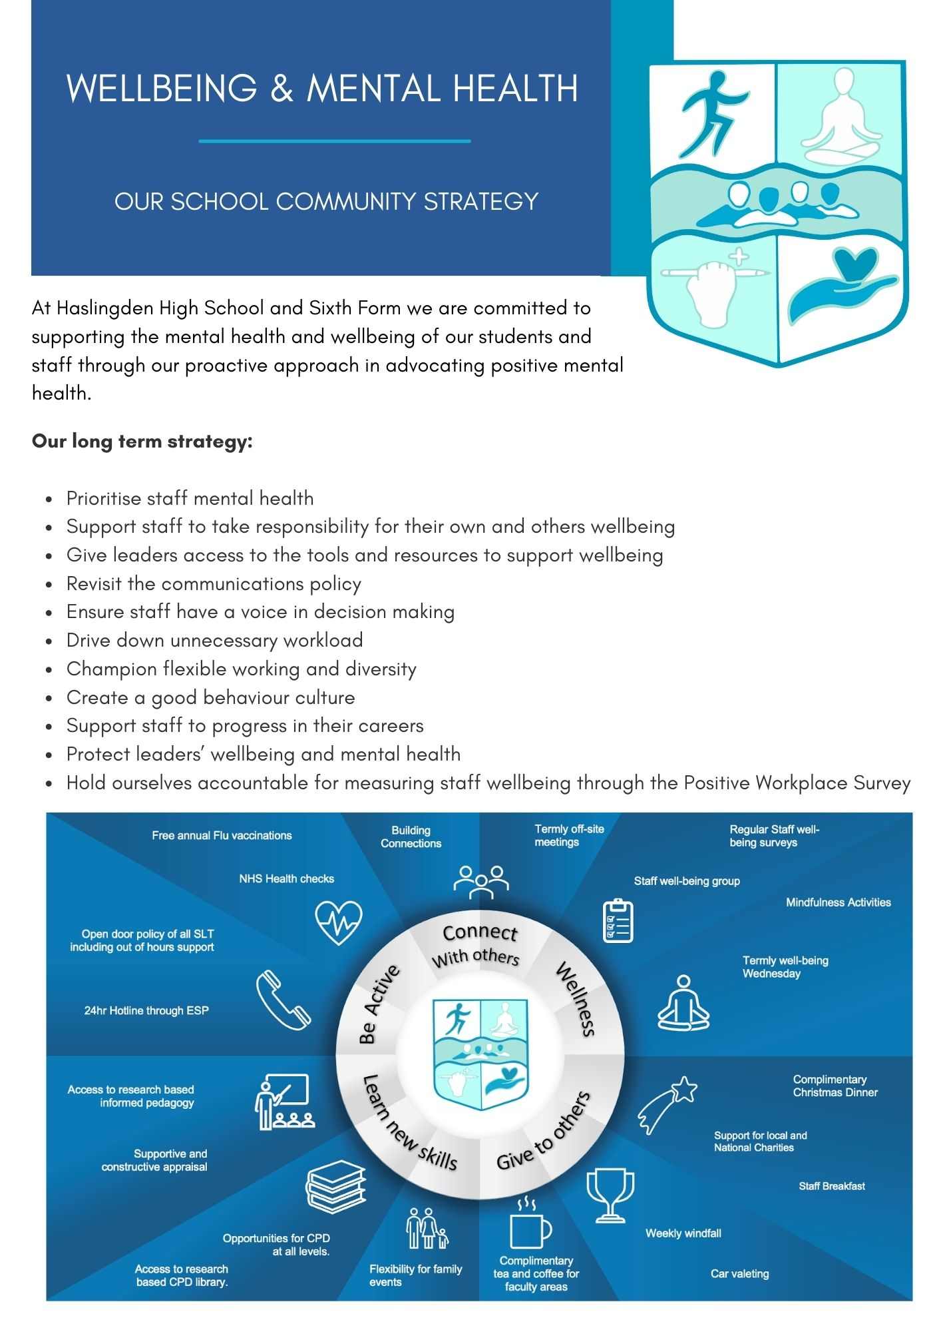

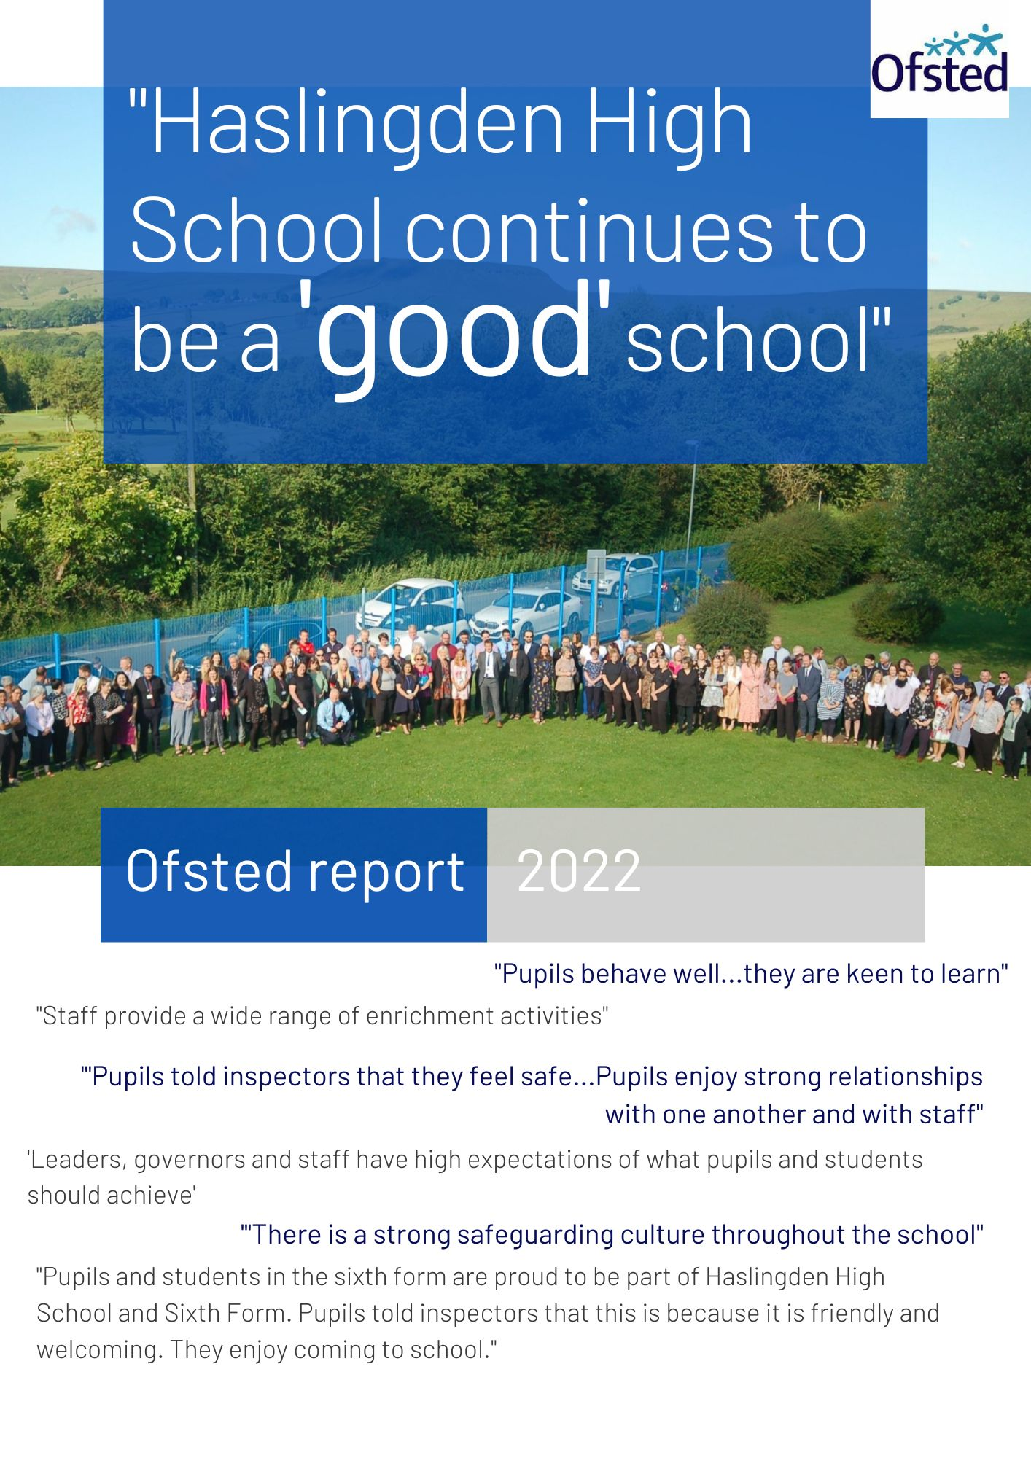
The full inspection report can be viewed here
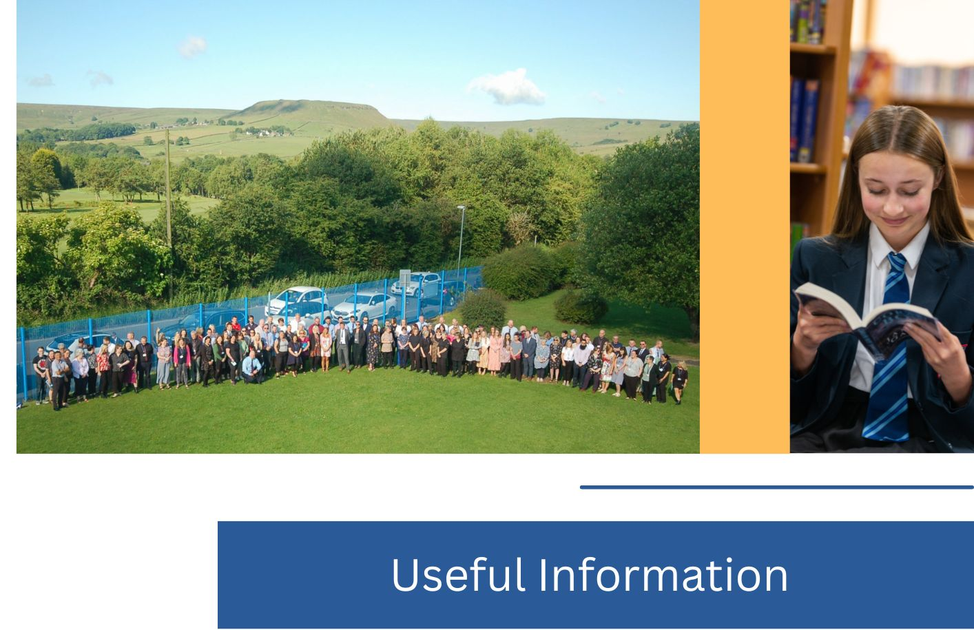

Thank you for your interest in joining our incredible team of staff here at Haslingden High School and Sixth Form.
Application forms can be found at the bottom of the vacancies section of our website.
Please email your application to vacancies@haslingdenhigh.com
If you have any questions, please do not hesitate to get in touch.



Haslingden High School and Sixth Form
Broadway, Haslingden, Rossendale, Lancashire, BB4 4EY
01706 215726
www.haslingdenhigh.com
@HaslingdenHigh HaslingdenHigh




