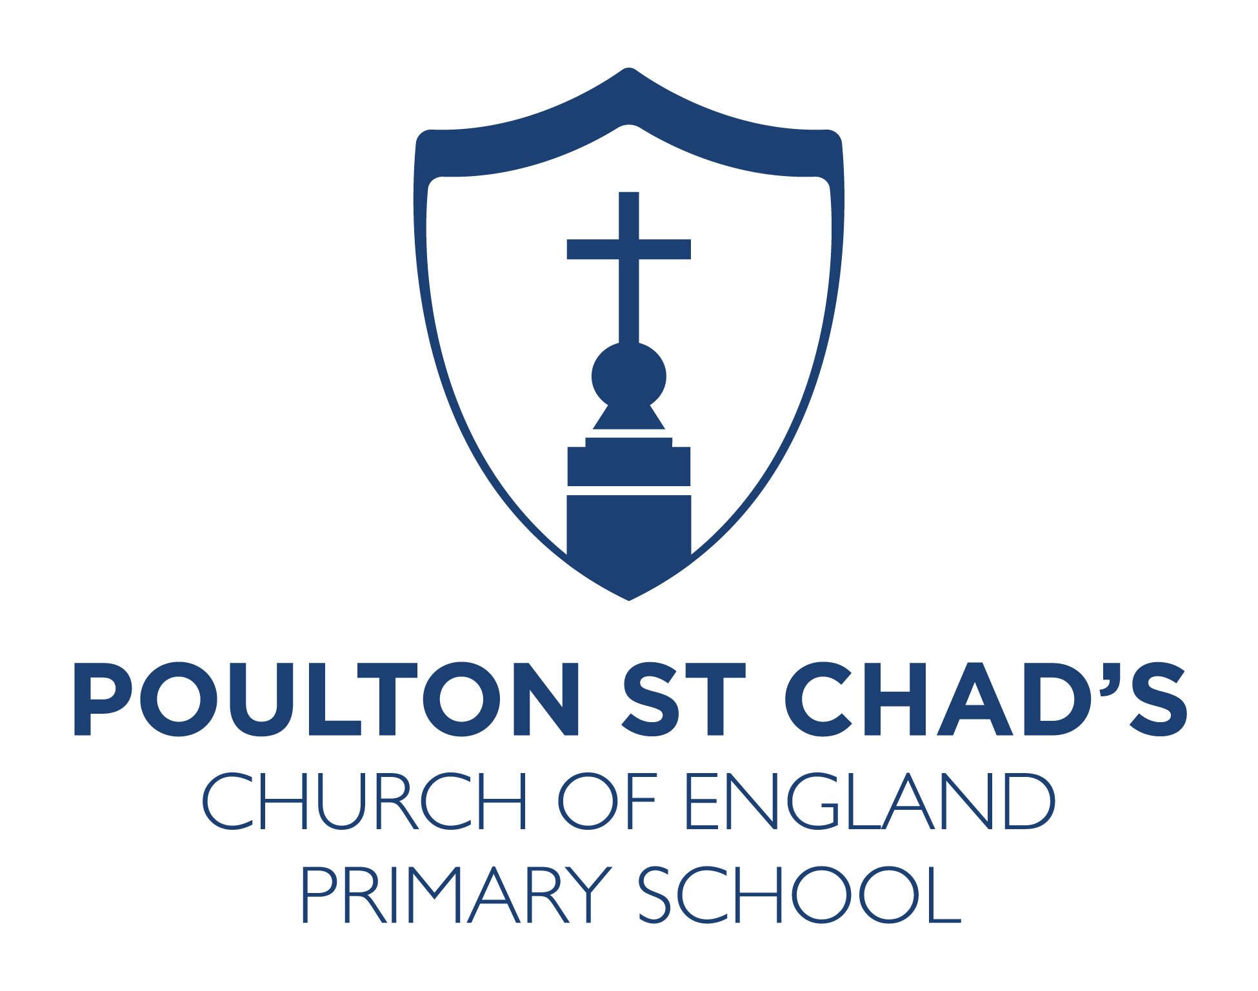

Job Title: KS2 HLTA Higher Level Teaching Assistant (Grade 7)
Hours: 30hrs per week
Start Date: 5.1.26 or sooner if available

Governors at Poulton St Chad’s C of E Primary are looking to appoint a permanent Higher Level Teaching Assistant who has the passion and enthusiasm to help children of all abilities reach their full potential and who will support teachers and SLT in continuing to raise standards across school. The postholder will be based in Key Stage 2.

We are looking for a someone who will:

- Be supportive of the Christian ethos of this school
- Have proven skills in inspiring children and helping to attainment in all subjects.
- Establish fair, respectful, highly inclusive and supportive relationships with children so that they can thrive
- Effectively communicate and work in partnership with families, carers, colleagues and other professionals.
- Have a good sense of humour!
- Be professional at all times
- Show emotional and professional resilience
- Be a hardworking, loyal member of our team who will contribute to making our school even better.

We can offer you:
- Wonderful, well behaved children
- Engaged, supportive parents.
- A friendly, experienced and supportive staff and SLT
- Commitment to your professional development.
- An environment where you will be valued and celebrated yet challenged to improve.
- A commitment to your wellbeing - happy staff are good staff.
- A supportive Governing Body, who are dedicated in their support of the school.
- Beautiful school grounds located in a highly desirable area.

Essential
- Experience of working within the primary age range
- Have a proven track record of delivering high quality whole class lessons and group interventions
- Be child centred and be prepared to put the needs of children of St Chad’s first at all times

Desirable
- HLTA Qualification
- Experience of working in different school settings
- Experience working with children from a range of backgrounds, with a range of behaviours and SEND
- Skills in Music, MFL or PE

Visits to school are welcomed and are encouraged on Thursday 6th November at 9:15 or 1:30pm or Monday 10th November at 430pm. Please email the Headteacher to arrange your visit on head@poultonstchadsce.lancs.sch.uk

If you would like to apply for this role, please complete the Diocesan application form. You will also need to write a letter of application- no more than 1 side of A4, in font size 12, supporting your application.

Please have a look at our website and social media for more information. Thank you for your interest in our school.

Closing Date: Wednesday 12th November 2025 (noon)
Shortlisting: Thursday 13th November 2025
Proposed Lesson Observations: Tuesday 18th November 2025 (morning)
Proposed Interview Date: Tuesday 18th November 2025 (afternoon)

Proposed hours

Monday 815-330 (45min lunch)
Tuesday 9-330 (30min lunch)
Wednesday 815-430 (45 min lunch)
Thursday 815-330 (45min lunch)
Friday 1-330
Plus 1 hr PPA (can be taken at home)

Term time only + 3 INSET days

We may have a small amount of flexibility on the hours- please get in touch if you have any questions.

