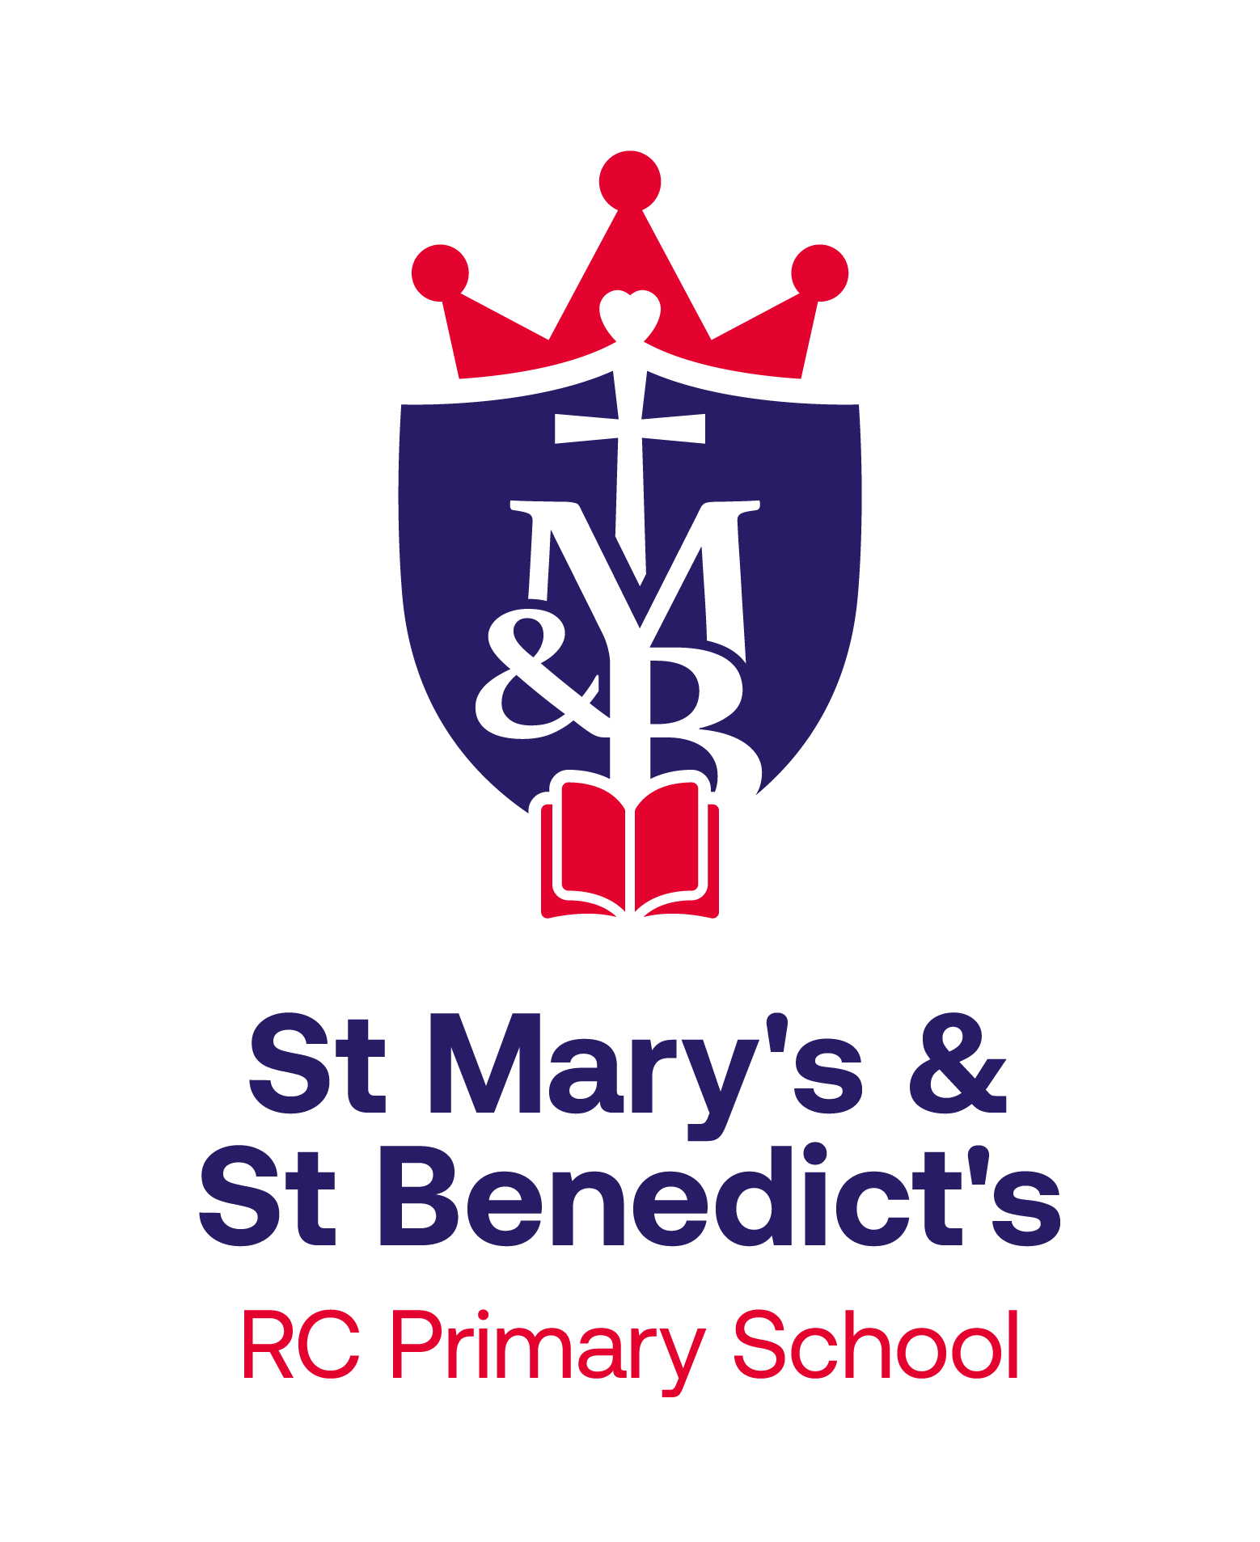
St Mary’s & St Benedict’s Catholic Primary School
Brownedge Lane, Bamber Bridge, Preston PR5 6TA
Phone: 01772 336650
Email: office@smsb.lancs.sch.uk
www.smsb.lancs.sch.uk
Headteacher: Mr Daniel Ballard

18th February 2025
School Business Manager (Grade 8)
Full time £35,235 - £39,513

The Governors at St Mary’s & St Benedict’s RC Primary School are looking to appoint an effective, highly motivated, enthusiastic and well organised School Business Manager with relevant experience and qualifications in financial management, health and safety, human resources, compliance and administration. We are a large, welcoming primary school where staff, pupils, parents and governors work hard together to provide children with the best care, education and support.
The role would suit someone who has experience of working as a School Business Manager in another school, or who can demonstrate how their experience and skills can transfer to our school environment. The successful candidate will support the Headteacher in achieving the school's development priorities and help develop the school's strategic direction by providing another perspective.
St Mary’s & St Benedict’s RC Primary School is committed to safeguarding and promoting the welfare of children and young people. Any appointment will be made subject to a clear, enhanced Disclosure and Barring Service (DBS) clearance.

If you are interested in becoming part of our team and helping us to continue our drive for further success, then we would be pleased to hear from you. Visits to the school are warmly welcomed. Please contact Mrs Jackie Altham 01772 336650 or office@smsb.lancs.sch.uk.

Applications should be submitted electronically to recruitment@smsb.lancs.sch.uk by noon on Friday 14th March 2025. Interviews will take place week commencing Monday 24th March 2025.

Please note we regret we are unable to contact individual applicants who may be unsuccessful at this time.
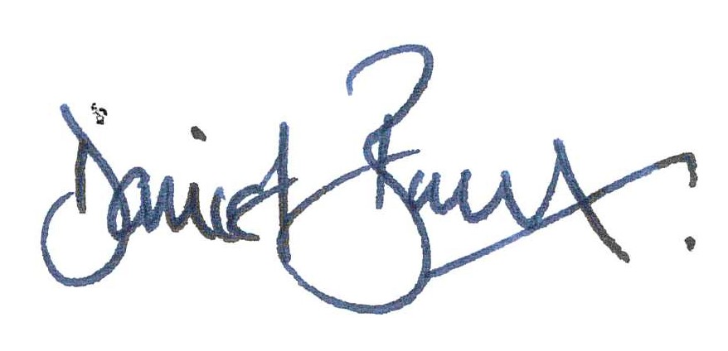

Mr Daniel Ballard
Headteacher

