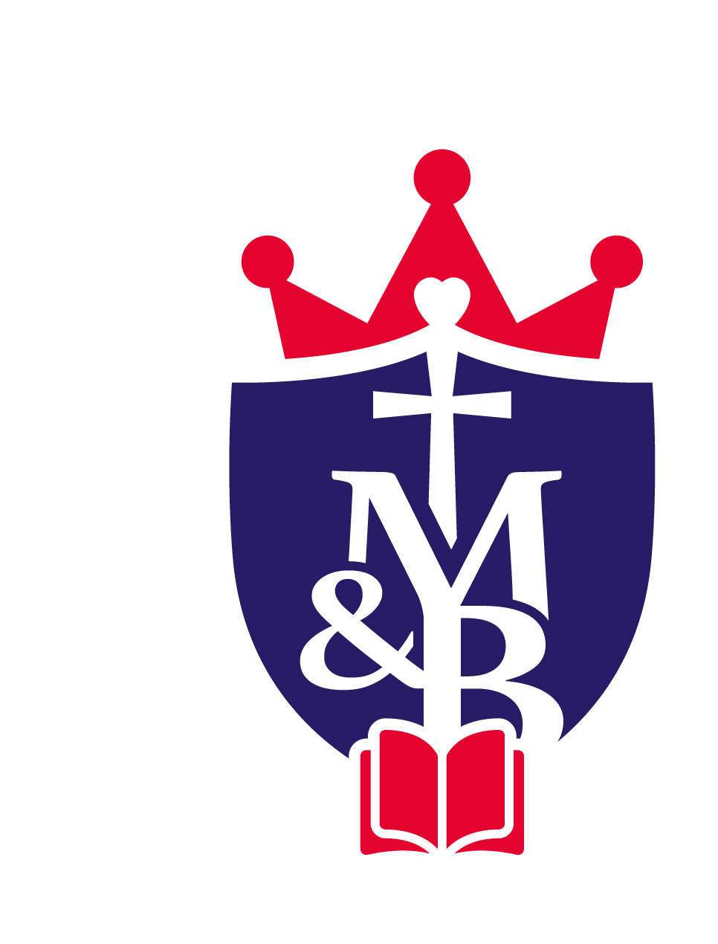

St Mary’s & St Benedict’s RC Primary

Person specification form
Job title: School Business Manager |  |  | Grade: 8
Directorate: Children and Young People - Schools
Establishment or team: St Mary’s & St Benedict’s RC Primary
Requirements (based on the job description) |  | Essential (E) or Desirable (D) |  |  | To be identified by: application form (AF), interview (I), test (T), reference (R)
Qualifications
• GCSEs including Maths and English Grade C or above |  | E |  |  | AF
• Achievement of the Certificate in School Business Management or relevant finance qualification |  | E |  |  | AF
• Accountancy experience/ qualification |  | D |  |  | AF
Experience
• Experience of working within a school office environment |  | E |  |  | AF/I
• Experience of relevant financial management, managing budgets, financial reporting, procurement and fixed assets |  | E |  |  | AF/I
• Experience of managing staff teams, including their professional development and performance management |  | D |  |  | AF/I
• Experience in managing Premises and Health & Safety |  | D |  |  | AF/I
• Experience in marketing and revenue generation |  | D |  |  | AF/I
• Experience of supporting Committees/Governing Body |  | D |  |  | AF/I
• Experience of working in a primary school setting |  | D |  |  | AF/I
• Experience of line managing admin and site staff |  | D |  |  | AF/I
• Experience of HR systems |  | E |  |  | AF/I
Knowledge, Skills and Abilities
• Ability to deliver services and systems applicable for effective school management |  | D |  |  | AF/I
• Ability to promote positive relationships with the wider school community |  | E |  |  | AF/I
• Excellent organisational, planning and analytical skills |  | E |  |  | AF/I
• Ability to devolve responsibilities, delegate tasks and monitor |  | E |  |  | AF/I
• Experience in the use of IT based management information and SIMS/FMS |  | E |  |  | AF
• Knowledge, understanding and interpretation of statistical data |  | D |  |  | AF
• Ability to maintain strict confidentiality at all times |  | E |  |  | AF/I
• Commitment to safeguarding & protecting the welfare of children & young people |  | E |  |  | AF/I
• Advanced use of Microsoft Office |  | E |  |  | AF/I
Personal Qualities
• Highly developed interpersonal skills |  | E |  | I
• Committed to the development and Catholic ethos of the school |  | E |  | I
• Able to work under pressure |  | E |  | I
• Flexible, approachable and able to work as part of the whole school team |  | E |  | I
• Resilient, reliable and enthusiastic |  | E |  | I
• Committed to own professional development |  | E |  | I
Other
• Commitment to safeguarding and protecting the welfare of children and young people |  | E |  | I
• Commitment to sustaining regular attendance at work |  | E |  | R
• Commitment to equality and diversity |  | E |  | I
• Commitment to health and safety |  | E |  | I
Prepared by: | J Altham | Date: |  |  | 17/01/2025
Note: We will always consider your references before confirming a job offer in writing.

