

Head Teacher – Mrs A Brogden
e-mail: head@lea-st-marys.lancs.sch.uk

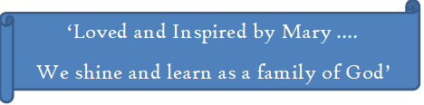

January 2025

Dear Candidate

Thank you for considering to work at our caring school. At St. Mary’s we pride ourselves on being kind and compassionate to all of our St Mary’s family. We would love someone who is willing to make our learning journey joyful. We hope that you can be the candidate to add to our already amazing staff members.

Yours Faithfully,

Annie and Harry, Head boy and Head Girl

