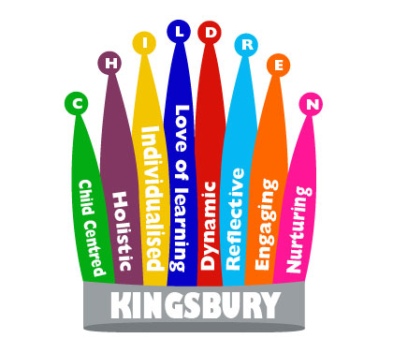

Teaching Assistant Level 3
Job description

Main Objective

- Expected to work with the teacher in a collaborative way, in meeting personal, social and curriculum related needs of pupils with special educational needs.
- Oversee and support Level 2 Teaching Assistants under the direction of the teacher.
- Establish positive, supportive and constructive relationships with children, parents, carers and the wider community.
- Contributing ideas and strategies to support the needs of children with a range of SEN
- Assist with the planning, delivery and evaluation of lessons.
- Plan and implement teaching and learning activities to individuals and groups
- Undertake supervisory cover for classes as appropriate.
- Establish supportive and constructive relationships with pupils, parents, carers and the wider community.

Main activities
Support for Pupils
To work collaboratively with the teacher in the planning, development, delivery and evaluation of the effectiveness of the curriculum for pupil(s) and to differentiate curriculum content according to the needs of pupil(s).
To plan and implement specific programmes with individual pupils or groups appropriate to the developmental needs of individual children throughout different curriculum areas.
To be fully involved in the planning and development of activities to support the personal, social and emotional needs of pupil(s).
To assist in the devising of pupil's individual targets and their monitoring and review
To support pupils with sensory regulation and lifestyle plans
To develop positive relationships with pupils and staff to assist pupil progress and attainment.
To monitor and record pupil progress on a regular basis and to prepare reports as required.
To assist in the specific medical/care needs of pupils when specific training has been undertaken.
Support for Teacher
To monitor individual pupils' progress and to report on pupils needs, achievements and concerns daily.
To assist in pupil supervision and the management of pupil regulation, having input in to Communication and Regulation Plans.
To undertake classroom administrative tasks including the maintenance of records
To provide ideas, resources and learning strategies for lessons
To liaise with parents, carers and outside agencies, where appropriate.
Using technology to monitor, record and communicate
Assist in the supervision of children on trips/visits and complete EVOLVE risk assessments for community visits.
Support for the School
To assist in providing a purposeful, orderly and supportive environment for learning.
To support the promotion of positive relationships with parents, carers and outside agencies
To work within school policies and procedures
To attend staff training/meetings as appropriate.
To take care for their own and other people's health and safety.
To liaise with the School's appropriate person with regard to the ordering supplies and equipment
To be aware of the confidential nature of issues related to home/pupil/teacher/school work
Assist in the supervision, training and development of other members of staff.
To undertake cover supervision for whole classes.
Monitor and manage stock, if necessary within an agreed budget, cataloguing resources and undertaking audits as required.
Support the Curriculum
To be familiar with the content of the school curriculum.
To assist in the delivery of appropriate programmes of work.
To support the use of ICT in learning activities

